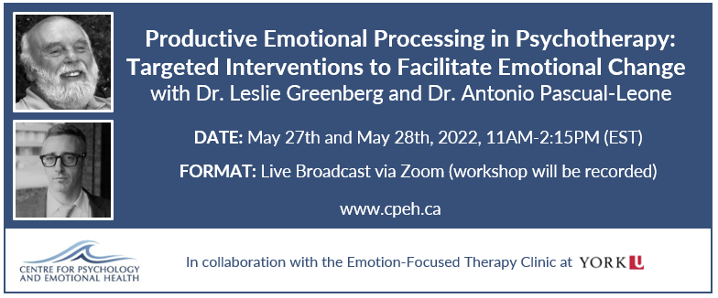

OVERVIEW
This workshop is designed by Dr. Leslie Greenberg and Dr. Antonio Pascual-Leone, leaders in the field of psychology. It is aimed at mental health professionals from various training backgrounds who wish to acquire specialized skills in processing emotions productively in psychotherapy. Video-recordings of therapy sessions will be used to illustrate client processes and interventions.

OBJECTIVES
This workshop will teach fundamental principles and practical skills on how to assess, process and transform emotions productively and how to transform unhelpful emotional schemes that underlie many mental health conditions. Participants will learn how to:

- Assess a client’s unique emotional processing style and emotional processing difficulties
- Learn interventions to facilitate emotional awareness, symbolize emotions, and deepen emotional experience
- Work with obstacles to productive emotional processing
- Guide a step-by-step emotion sequence to transform unproductive emotional states into productive emotional states
- Promote memory reconsolidation and emotional change by meaning-making, narrative elaboration, and co-creating new narratives

REGISTER

