MAY 2021
Annual Newsletter
CREATIVE ARTS IN COUNSELLING AND PSYCHOTHERAPY CHAPTER

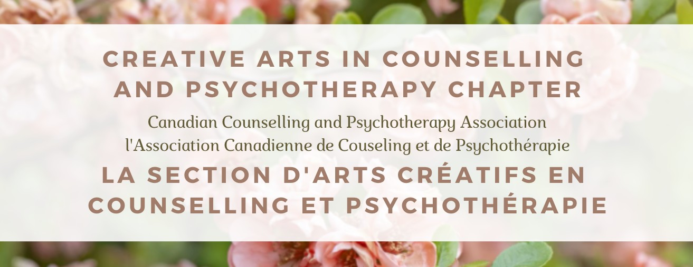

Welcome CACP Chapter Members!
In this year's issue we will highlight several of our chapter's ventures, from May 2020 to April 2021. We will explore upcoming initiatives, including our upcoming speaker-working group series, Creative Arts Therapists ("CATS") Against White Supremacy. This year's issue is intent on the professional need to amplify and uplift the voices of creative arts therapists from minoritized communities, specifically the voices of Black, Indigenous, and Creative Arts Therapists of Colour. Our newsletter article features an interview-style discussion between the organizer and facilitators of the 2020-2021 CATSOCAAA speaker-discussions series which explores the experiences of BIPOC students, alumni, and professionals in the creative arts therapies field. We will also be taking a look back at the recipients of our 2020 funding initiatives and the projects they completed, as well as the array of CATS interventions, challenges, and advocacy from chapter members. This newsletter is a vignette into the ongoing discussions that need to continue to grow. We thank you for being here and encourage you to share the newsletter and its contents widely!
Inside this Edition
A WORD FROM OUR PRESIDENT PG. 2
MEET OUR BOARD OF EXECUTIVES ...........................................................................................................................................PG. 3 CCPA CONFERENCE: MAY 13-15 2021 + CACP PANEL DISCUSSION .........................................................................PG. 5 2020 BURSARY RECIPIENTS.............................................................................................................................................................PG. 6 FUNDING RECIPIENTS: COVID-19 AND SPECIAL PROJECTS.........................................................................................PG. 7 2021 BURSARY RECIPIENTS..............................................................................................................................................................PG. 8 COMING SOON: CATS AGAINST WHITE SUPREMACY .....................................................................................................PG. 9 A CACP SPEAKER-DISCUSSION SERIES
JOURNAL CLUB ARTICLE FEATURE ..........................................................................................................................................PG. 10
NEWSLETTER ARTICLE FEATURE ...............................................................................................................................................PG. 11 IN CONVERSATION WITH THE CREATIVE ARTS THERAPISTS BEHIND THE CATSOCAAA SPEAKER SERIES & DISCUSSIONS
UPDATE FROM OUR STUDENT REPRESENTATIVE..........................................................................................................PG. 20
GET INVOLVED WITH THE CACP .................................................................................................................................................PG. 21
RESOURCE LISTS FOR YOU.............................................................................................................................................................PG. 22
UPCOMING EVENTS AND OPPORTUNITIES..........................................................................................................................PG. 23
THE "ART" OF SELF-CARE..................................................................................................................,..............................................PG. 24

ANNUAL NEWSLETTER
PAGE 1

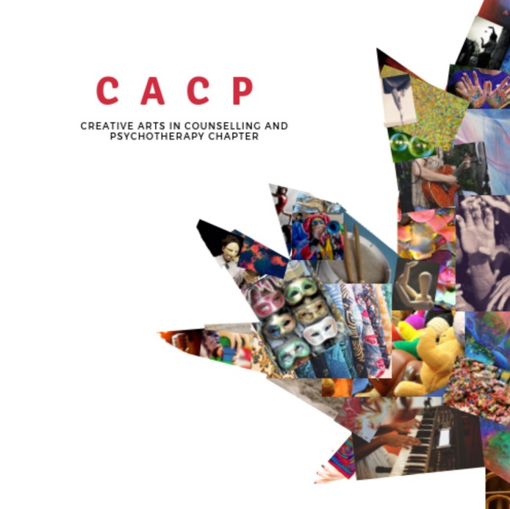
MAY 2021

A letter from the CACP Chapter President
Rowena Tam, M.A., C.C.C.
Creative Arts Therapist | Researcher | Artist
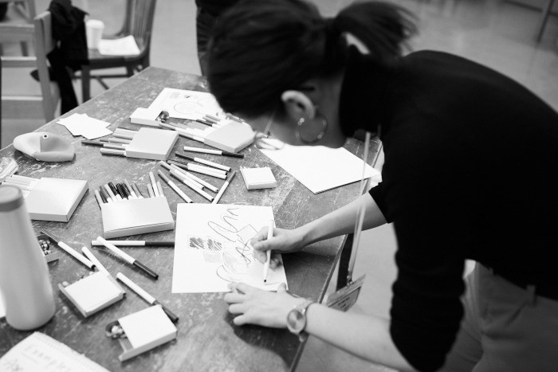
Dear CCPA conference delegates and Members of the Creative Arts in Counselling and Psychotherapy (CACP) Chapter,
Welcome to this year’s chapter annual newsletter. I want to begin by acknowledging how ongoing state-sanctioned violence, settler- colonialism, racial capitalism, in tandem with a second pandemic year, have intensified experiences of insurmountable grief and loss.
Professionals in the counselling, psychotherapy, and creative arts
therapy fields have been oscillating

between feelings of burnout, anxiety, fatigue, and tension, while
photo taken by Kevin Bryan at UofT's Centre for Drama, Theatre and Performance Studies's Festival of Original Theatre (FOOT) 2019 Conference

caretaking for loved ones, and showing up to hold space for clients. I hope that amidst
all this, you are also showing up for you. Allow yourself space to breathe, sit with yourself, reflect, grow and nourish your spirits.
The CACP Chapter serves as a vehicle to engage in open dialogue, advocacy, and visibility on research, training, and practice in the creative arts therapies. This year’s annual newsletter would not be possible without the fierce dedication, commitment, and leadership from creative arts therapists across settler-colonial Canada. I want to thank our membership for your resiliency and creative efforts. I am in constant awe at the energy you bring to this field. I’d also like to extend my sincerest gratitude to the chapter’s executive team: Lorelei Dietz, Audrey-Anne Frenette, Rachel Norris, Stephanie Sing, Angie Ross, Gabrielle Gingras, and Leah Lewis, for propelling this chapter forward to better serve our membership and community.

As the world witnesses the disproportionate rates of Black, Brown, Asian, and Indigenous community members accounting for the majority of deaths during COVID- 19, in addition to the murders, and uproar from protests responding to these crises, it is futile for our chapter to sit back and do nothing. These communities are representative of our membership, students, colleagues, clients, peers, loved ones, and society. As the NADTA (2015) states, it is our cultural response/ability to uphold professional and ethical competencies in our training, research, practice, supervision, advocacy, and organizational change. This year’s newsletter focuses on the many

ANNUAL NEWSLETTER PAGE 2

MAY 2021

ways in which our chapter is creating, supporting, and uplifting Black, Indigenous, and creative arts therapists of colour in their professional, personal, and academic endeavours.

As the end of my two-year mandate as President of the CACP Chapter approaches, I am honoured to “pass the torch” and introduce our chapter’s incoming President, Lorelei Dietz. Lorelei joined our executive team in 2019, and has served as our Student Representative and Communications Director. Lorelei is a music therapist based in K’jipuktuk (Halifax), Nova Scotia, and has quickly demonstrated her eagerness to learn and acquire leadership skills. Her talent and experience both within the chapter and in her personal and professional life is a testament to her growth and appointment to this position. I am confident that Lorelei’s radiant passion for the creative arts therapies will carry the chapter’s fiery momentum forward.

On behalf of the executive team, we hope you can find time to rest, take care, and create moments of safety for yourself as we work together to build a safer community in the field of creative arts therapies. We wish you a good read and look forward to hearing from you soon.

Creatively yours, Rowena Tam
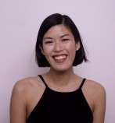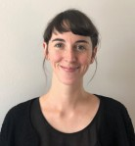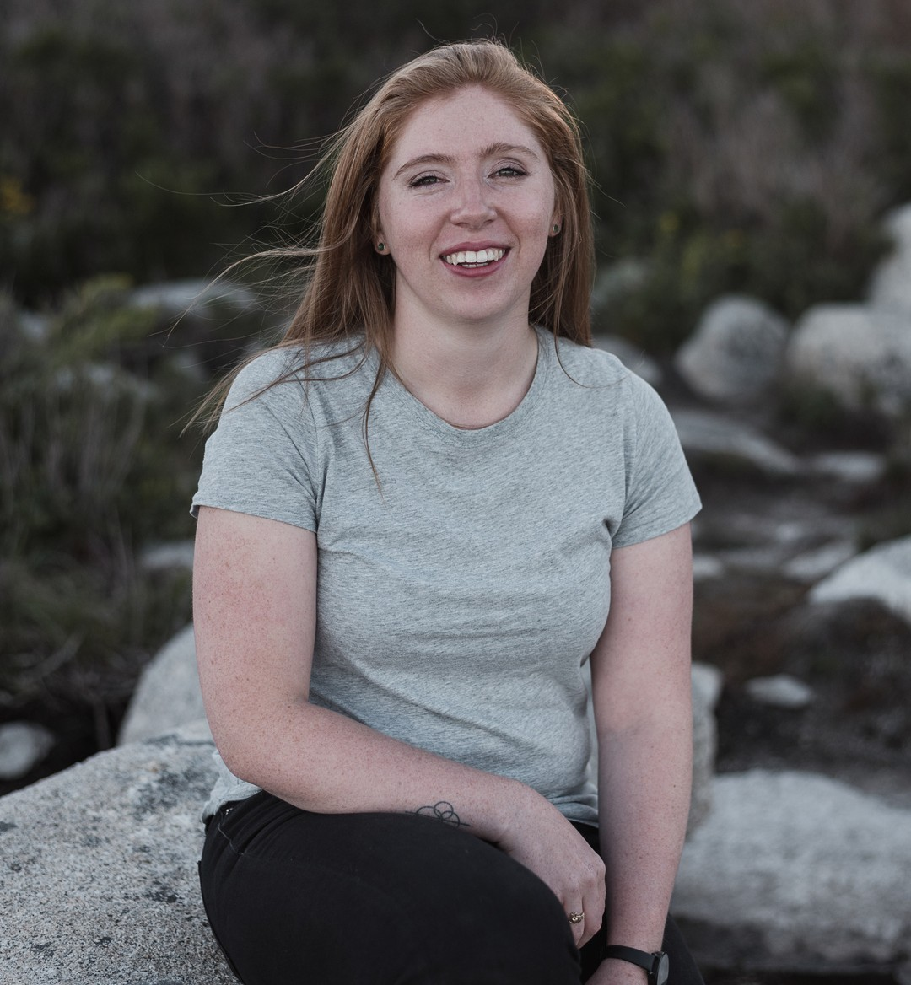
Meet our Board of Executives

Rowena Tam
President
Gabrielle Gingras
Past-President
Audrey-Anne Frenette
Treasurer
Lorelei Dietz Communications Director and Student Representative

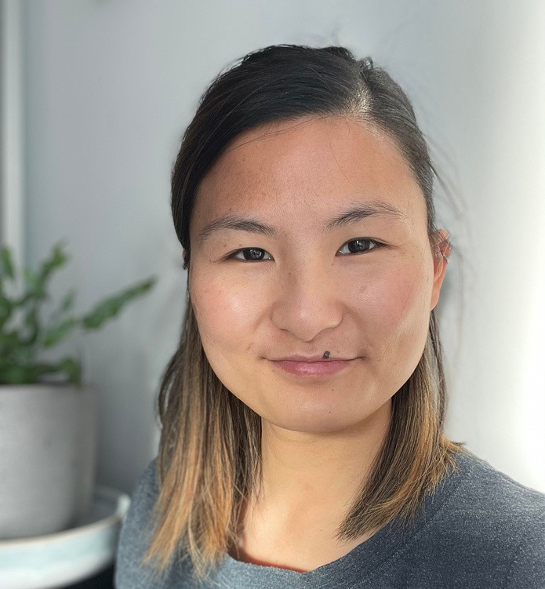
Stephanie Sing Communications Specialist

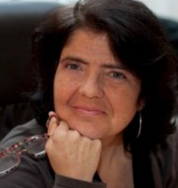
Leah Lewis
Board Liason
NEW
MEMBERS!
Special Projects Coordinator &
Treasurer

ANNUAL NEWSLETTER PAGE 3

MAY 2021
Rachel Norris, Special Projects Coordinator
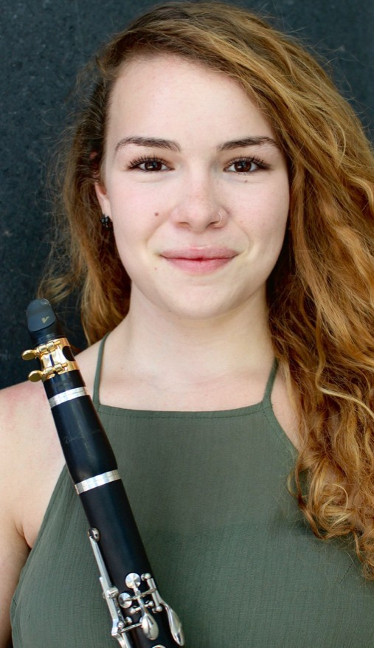
Rachel Norris (MTA, MT-BC) is a board-certified Music Therapist in the Montreal area. Rachel obtained her bachelor’s in clarinet performance with a minor in psychology from McGill University in 2013. During her time at McGill, Rachel studied music education courses and was a Little Musician Instructor teaching early music skills to pre-school aged children. Rachel completed her Graduate Diploma in Music Therapy at Concordia University in November 2019. During this time, Rachel interned with children with significant disabilities and visual impairments, and at-risk mothers and their children. Rachel is a Level 1 certified Play therapist and is also a certified Music Together instructor teaching group music classes for families. Rachel currently works in private practice working with adults with developmental disabilities and has contracts working with at-risk mothers and their children in a residential home. A recent graduate of the Master's in Music Therapy at Concordia University, Rachel has researched the use of attachment theory in music therapy clinical practice

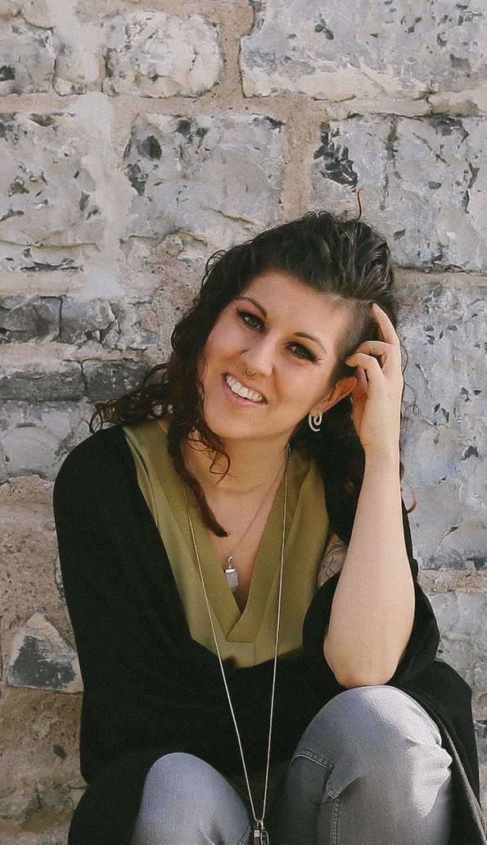
Angie Ross, Secretary
After a brief dance career, Angie has been working on completing her Masters in Drama therapy at Concordia University. Her interest centers around the embodied experience of trauma. She has clinical experience with neurodiverse adults and children as well as elders within a community setting. Her current work centers around therapeutic support for performers through their process with sensitive topic. She also works with neurodiverse children in a center for neurodevelopment. Her current thesis research focuses on the biopsychosocial effects of trauma and healing benefits of the creative arts therapies. Angie works towards decolonizing her work and acknowledges she lives on unceded territory of the Kanien’kehá;ka Nation who are the custodians of the lands and waters of what is now known as Montréal.

Welcome to the CACP Executive Team!

ANNUAL NEWSLETTER PAGE 4

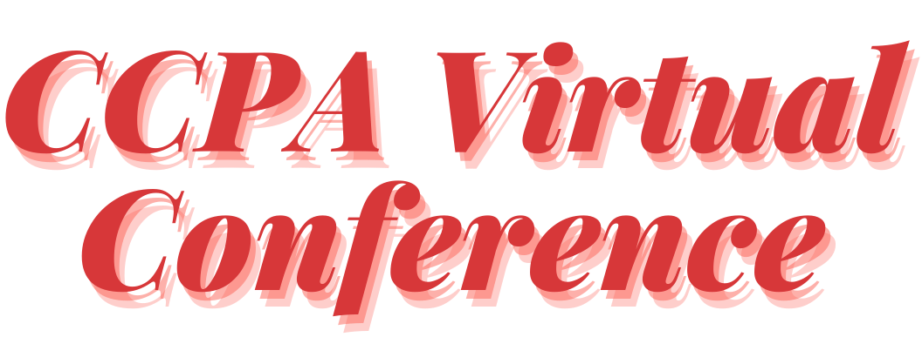

May 13-15, 2021
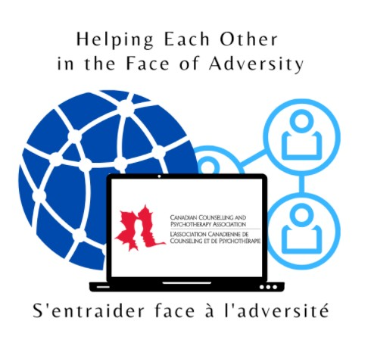
There's still time to register!

Featuring our Panelists:
CACP Conference Panel
The Intersection of Neuroscience and Art: Regulating the Nervous System using Creative Arts Therapy Interventions
May 15th, 2021 5pm EDT

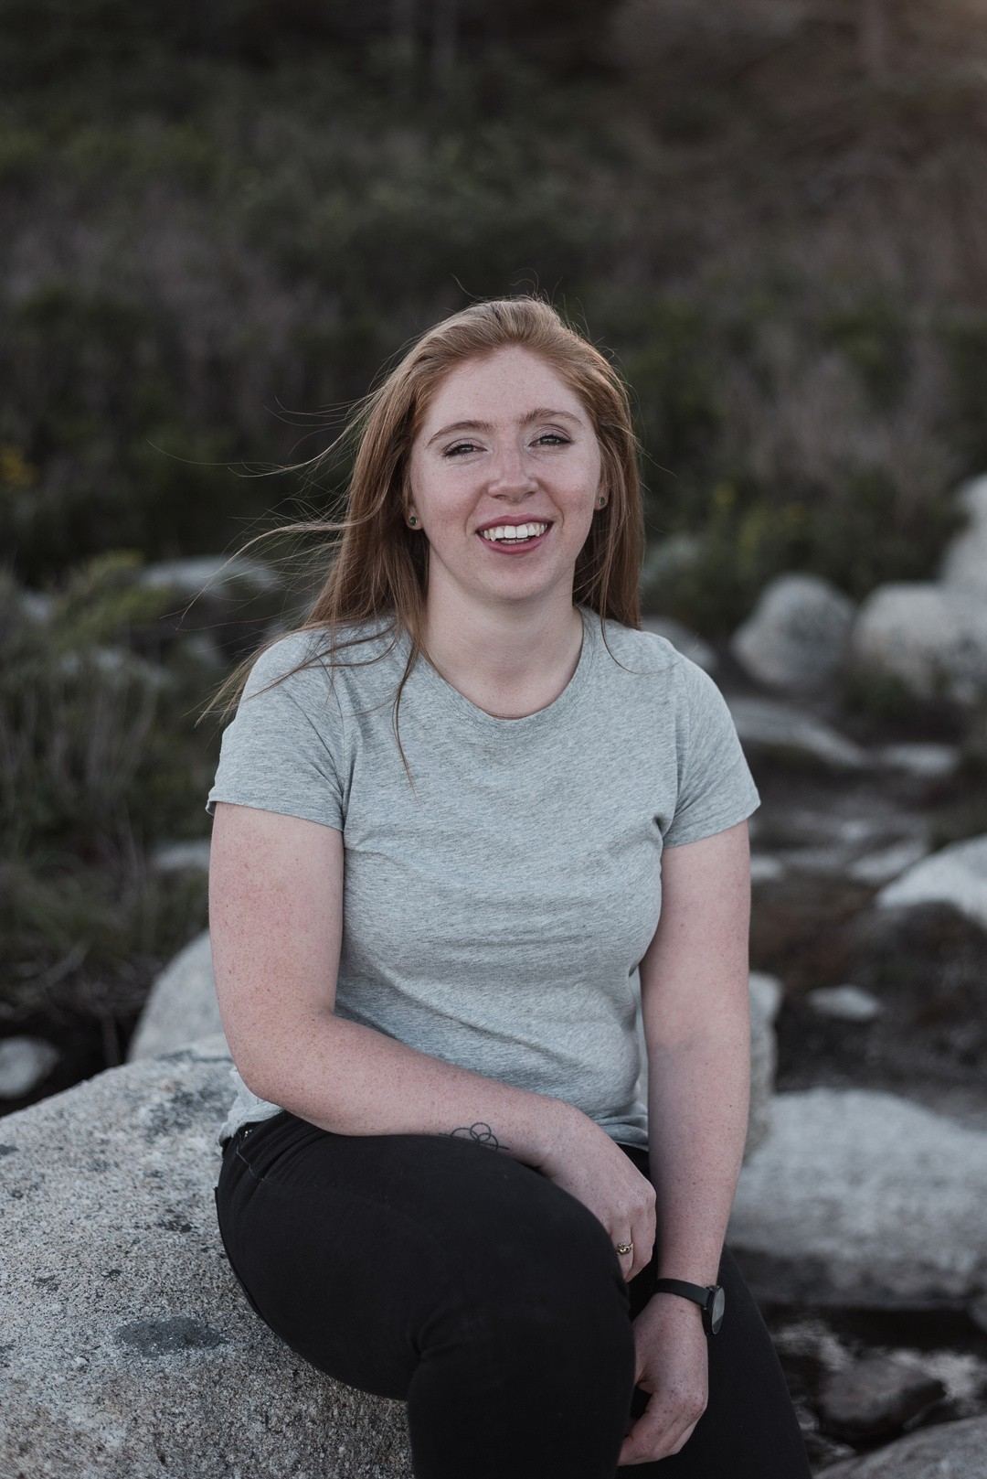
Lorelei Dietz, B.Mus, MTA, NMT
Lorelei Dietz is a music therapist (MTA, NMT) and founder of Coastal Music Therapy, a mobile music therapy practice in Halifax, Nova Scotia (K’jipuktuk). Through a mix of music, discussion, and mindfulness-based techniques, she strives to help others work towards their health-related goals. As a certified Neurologic Music Therapist (NMT), she specializes in using music therapy in a rehabilitation capacity. Lorelei is a Master’s candidate in Music Therapy at Concordia University, researching how collaborations between music therapy and neuroscience can inform practices and be applied in clinical settings. Lorelei also serves as the Communications Director for the CACP Chapter.

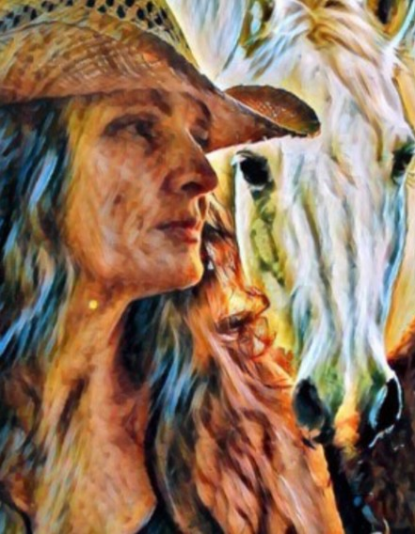
Nicola Sherwin-Roller, MA, CCC, RCAT
Nicola Sherwin-Roller (she/her/hers) graduated in 1994 from Concordia university with a master’s in art psychotherapy. Nicola has been in private practice since 1997, prior to that she worked in second level health services with a First Nation Government organization. Nicola is the Saskatchewan Director for CCPA, on the steering committee for FACT-SK and is a member of the advocacy committee with CATA. Nicola acknowledges that she is a settler on the lands of the Treaty Six Nations and homeland of the Metis people. She works in Kistapininihk (The Gathering Place) Prince Albert, Saskatchewan and resides in the countryside nearby.

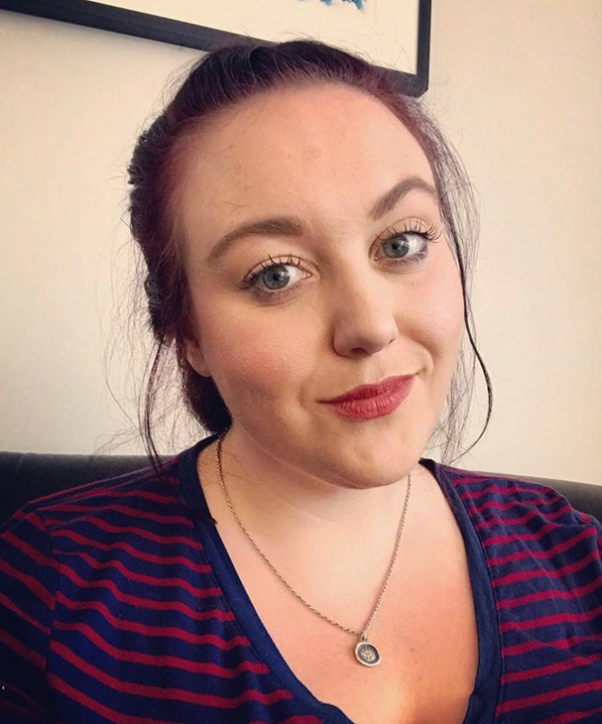
Cayley McConaghy, MA, CCC, RDT
Cayley McConaghy is a Registered Drama Therapist and Certified Canadian Counsellor. Graduating with a Master’s degree from Concordia’s Creative Arts Therapies program (specialization Drama Therapy) in 2017 Cayley now lives in Amiskwacîwâskahikan (Edmonton). She currently works with children, youth, and adults in both school and community clinic settings. Working as a theatre artist before graduate school Cayley has long believed in the therapeutic qualities of drama and is continually amazed by the power it brings to her practice and her clients. Cayley also sits on the board for the Association of Counselling Therapy of Alberta.
ANNUAL NEWSLETTER PAGE 5

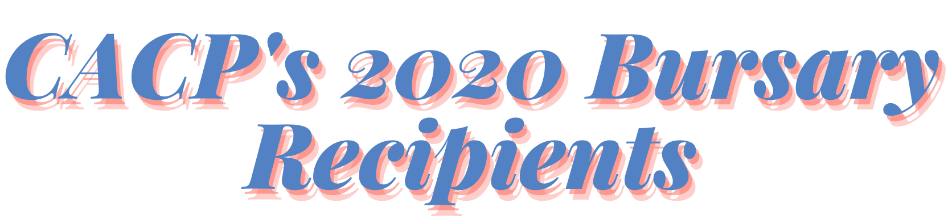

Professional Bursary: Ashlee Hollinger, Art Therapist

Project: Examining the needs of women accessing shelter services through trauma- informed practices using art therapy.
"The original goal of this project was to incorporate an art therapy group within a larger mental health service project within the shelter system, focused on trauma. Unfortunately, as the pandemic entered its second wave, we were unable to deliver this specific project. However, there was another very prominent theme occurring as a result of the recent events which took place over summer 2020, around the topic of racism, racialized trauma, and the Black Lives Matter movement.

The Breelove team responded to this by offering psychoeducational webinars to various peoples, groups, and companies within Atlantic Canada on the topic of Race and Privilege. In collaboration with our clinical traumatologist who is also a racialized person, along with our counselling therapist who specializes in art therapy and EMDR, we set to deliver a reflective space, where not only were participants offered an opportunity to learn more about race and privilege, they were also given the opportunity to reflect on privilege and oppression, through art-making.

Art-making was offered as a way to deepen reflection and learning and to help participants metabolize the concept of privilege and oppression and the ways it shows up in their daily lives, perhaps unconsciously."

Professional Bursary: Michelle J. Buckle, Drama Therapist

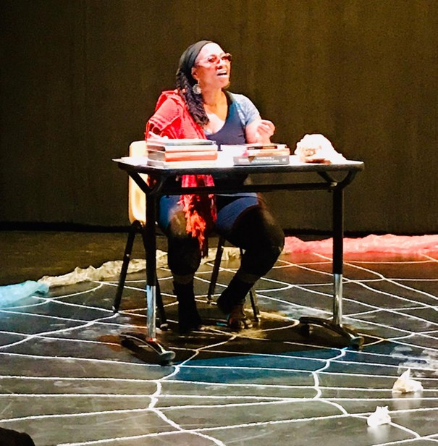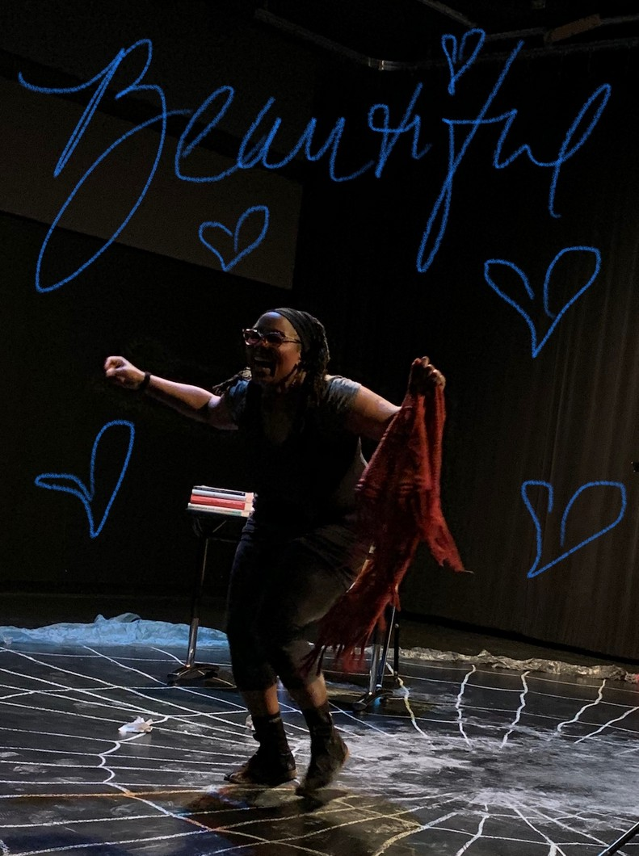Project: Bringing together communities to better understand the lived experiences of Black co-victims of homicide using an autoethnographic performance and the Anansi character to address their stories.
"It is with humility and profound gratitude that I received this bursary which allowed me to engage in research throughout 2020. My findings enabled me to learn about my own socio- cultural history and the impact that trauma and colonisation has had on my family system. I interviewed family and community members about stories or histories reflecting my community. I also explored traditional folklore and stories to better understand the values and teachings that are inherent in my culture.

Using various artistic mediums I was able to explore traditional stories and relate them to personal and collective experiences. After creating an autodrama script from the research I was able to produce an autoethnographic therapeutic performance. This performance was presented 4 times, recorded and made available for academic, professional and personal and public viewing.

The show was presented at the North American Drama Therapy Association (NADTA) 2020 conference in November 2020, and will also be submitted for two upcoming conferences in May and June 2021: The Canadian Counselling Psychotherapy Association (CCPA) Conference and the Children, Youth & Performance Conference, respectively. "

ANNUAL NEWSLETTER PAGE 6

At the beginning of the pandemic in 2020, the CACP Chapter recognized the unforeseeable changes that were required of creative arts therapists and counsellors. To support the difficult adaptations and transition to working online or in-person during a global pandemic, the CACP Chapter launched a COVID-19 Support Fund to help our members engage in workshops, virtual gatherings, researching resources or find new ways to respond to the COVID-19 crisis. Members applied through a survey generated by the chapter and CCPA, and disbursed $200 to support 7 creative arts therapy projects.

Congratulations to the 7 funding recipients!
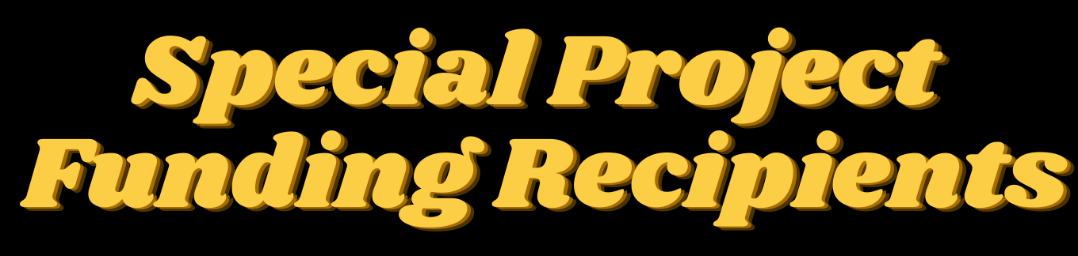
2020

The Continuing Education Collective for Psychotherapists of Alberta
"The Continuing Education Collective for Creative Psychotherapists (Alberta) was created to fill the need for more connection between practicing therapists who often experience isolation due to many factors. At this time the Collective is open to any creative therapist in Alberta. This includes a variety of modalities, art, dance, expressive arts, drama, music and others. This Fall, we were able to use money from the CCPA Creative Arts Chapter to hire Jennifer Buchanan to speak to the group about ways of pivoting towards a successful private practice in Alberta, as creative arts psychotherapists. As a successful business woman and music therapist, Jennifer’s presentation was well received and gave the attendees much needed guidance, support and inspiration to continue to take on this unique challenge. Thank-you Creative Arts Chapter for making this possible."

Inner Landscapes
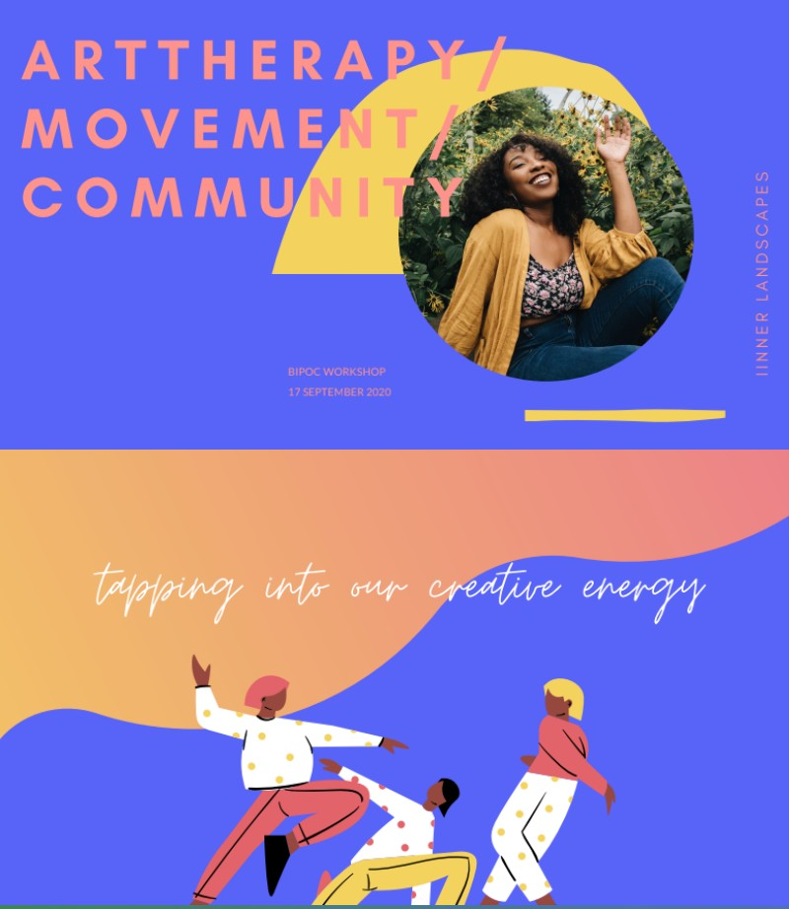
Inner Landscapes was a virtual art therapy & mindful movement workshop for BIPOC delivered in the fall of 2020. Over 45 BIPOC participants from across Canada, the US, and beyond joined us for collective art- making and mindful movement.
The theme of the workshop was the change in seasons, and we used art and mindfulness exercises to explore how we relate to change, and what change looks like in our new shared
reality post COVID-19.

The workshop was delivered virtually, which allowed us to share the creative arts therapies with participants who would, in other circumstances, be out of reach. Participants were welcomed
into the shared virtual space, led through low-impact, mindful movement exercises, and then guided in an art-making activity. Participants were encouraged to share and reflect openly throughout and after the art-making process, and many found their individual experiences reflected in those of other participants. The workshop was able to cultivate a shared feeling of community, creativity, and connection for all who were present.

ANNUAL NEWSLETTER PAGE 7

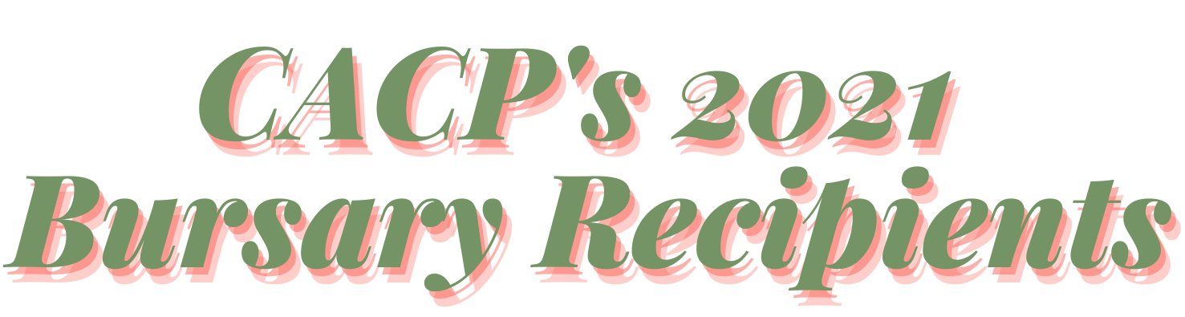

Professional Bursary: Mallory Minerson, Drama Therapist

Project: Developing an Introduction to Drama Therapy Course at St. Stephen’s College

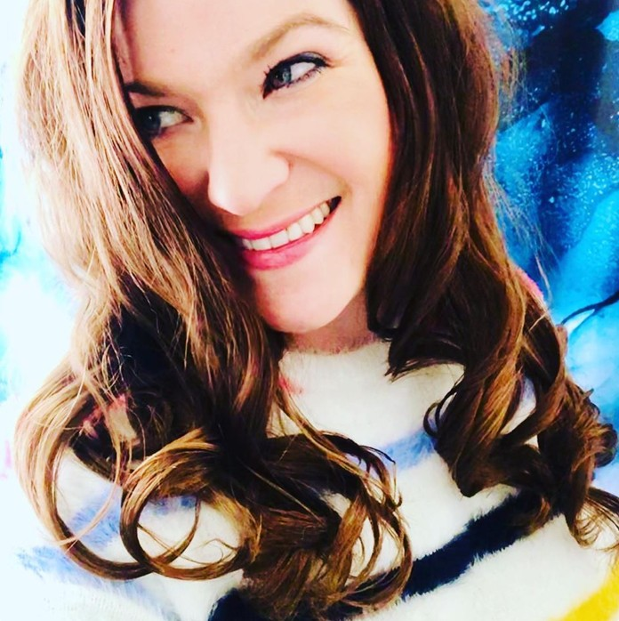
Mallory Minerson has an MA in Drama Therapy from New York University. Mallory’s work is multimodal, trauma-focused and is guided by embodied arts-based research. For the past three years she has worked with an all-ages population in community, individual and school-based sessions in a remote, Northern Canadian community highly impacted by the burden of cultural genocide and the Residential School system and its abuses.
Ms. Minerson primarily trained at the notorious Bellevue Hospital in Manhattan, in forensic psychiatry, with incarcerated men who presented with complex mental health issues and psychosocial intersectionality. She has facilitated group drama therapy at
.Calgary’s Southern Alberta Forensic Psychiatry Centre (SAFPC).
Ms. Minerson is passionate about moving drama therapy into the quantitative research domain to measure the inherent benefits of embodiment and arts-based healing engagement, and is interested in the overlap of medical humanities, arts-based research, drama therapy and narrative medicine.

Mallory is a Registered Drama Therapist, Certified Canadian Counsellor, Clinical Traumatologist (Traumatology Institute) and Licensed Practical Nurse. She is the current Government Affairs Chair for the North American Drama Therapy Association. www.malloryminerson.com

Research Bursary: Cassandra Brennan, Drama Therapist
Project: Public practice drama therapy with women in the criminal in/justice system
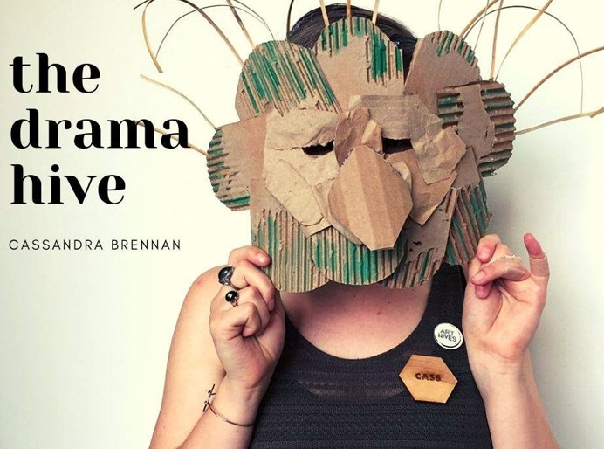
Cassandra Brennan is a settler, drama therapist and artist based in the Greater Toronto Area, in the traditional lands of the Mississauga’s of the New Credit. Since graduating from Concordia University’s Drama Therapy program, Cassandra has worked with individuals and groups in various crisis intervention and community settings. Cassandra is currently working in private practice, while also seeking ways to bring her research to fruition. Cassandra is passionate about furthering conversations related to public practice drama therapy and devising new, more radically inclusive approaches to the field of drama therapy.

ANNUAL NEWSLETTER PAGE 8

MAY 2021

An Upcoming Speaker-Discussion Series

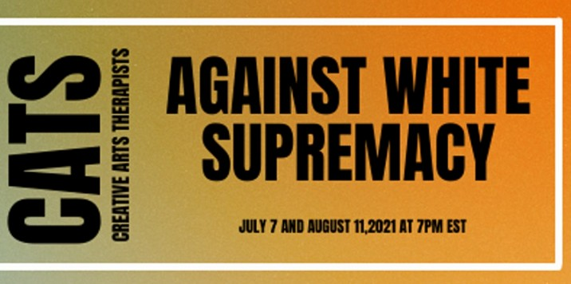

Inspired by the NADTA's Cultural, Humility, Equity and Diversity Committee's campaign #DramaTherapistsAgainstWhiteSupremacy, the Creative Arts in Counselling and Psychotherapy Chapter will host a monthly two-part series of speakers and working groups that aim to challenge and dismantle white supremacy within ourselves, our communities, and our professional field. As creative arts therapists, it is part of our professional, ethical, and cultural response/ability to enhance and understand how our experiences are affected by racism, capitalism, and colonialism.

This event is open to all creative arts therapists, expressive arts therapists, and therapists from adjacent fields with affiliation to Canadian creative arts therapy organizations [CATA, CAMT, NADTA, ADTA].

Part 1 - Speaker workshop: Wednesday July 7th from 7:00-800pm EST Part 2 - Working Group: Wednesday August 11th from 7:00-800pm EST
* Upon registration, attendance to both parts of the series is mandatory.

EVENT DETAILS
This months speaker will be Stephanie Sing (she/her) who is a bicultural art-therapist (M.A) currently practicing in the Greater Toronto Area. Her interests gravitate toward individuals and communities whose lives have been touched by a traumatic experience, especially those related to broader systemic problems. Stephanie’s clinical experience varies in scope and has included working with: individuals living with dementia, women and children fleeing domestic and honour based violence, incarcerated women, newcomers, and communities afflicted by drug and gang violence. Stephanie is a strong believer in empowering formally disenfranchised groups and assists those she works with by using a trauma-informed lens as well as closely referencing the community resiliency model.

Following the speaker session, attendees will participate in a mandatory follow up working group, facilitated by Rowena Tam, CACP Chapter President on Wednesday August 11, 2021. The working groups will hold us accountable, and will ensure that we are not just listening but are actively reflecting and responding in constructive and actionable ways in various settings in the month between the events. Committing to this work, both within our working groups and within your personal lives, is a life-long journey. Your participation in both seminars is an essential component to the process of dismantling white supremacy and its indoctrination within us all.

To learn more and/or register for the event check out our Eventbrite page!

ANNUAL NEWSLETTER PAGE 9

MAY 2021

CLOSED GROUP: June 9th, 2021

Join us on Wednesday June 9th from 7:00-8:00pm EST for a 1-hour closed BIPOC discussion group to discuss how white supremacy and systemic racism affect our experiences, education, profession, and lives as creative arts therapists of colour. This discussion group will be facilitated by the CACP President Rowena Tam. The following Speaker Series and Workshops will magnetize and address the present and pervasive systematic issues that exist within our field.

Please note: this group is ONLY open to BIPOC creative arts therapists, to ensure a safe meeting space. Subsequent speaker and discussion meetings will be open to all creative arts therapists.
**Opportunity for participants to receive a $35 gift card to Chapters/Indigo as an honorarium. All registered BIPOC attendees who are CACP members and participate in the entire group discussion are eligible. Limited gift cards available. Our special projects coordinator, Rachel Norris, will reach out to you after the event with more information.

To register, check out our Eventbrite here.

"What are You All Going to Do to Keep Black Women in Art Therapy?"
Article Feature
A Womanist Manifesto for Creative Arts Therapies Education

By Leah Gipson, Marisol Norris, Leah Amaral, Johanna Tesfaye, Anna Hiscox Published April 2021

This article explores the viewpoints of authors Leah Gipson, Marisol Norris, Leah Amaral, Johanna Tesfaye, and Anna Hiscox: "the authors describe their impressions of a 2018 conference and the significance of participating in a learning environment that centered on arts therapists of colour. Collectively, two art therapy educators, a music therapy educator, one new professional art therapist, and one art therapy graduate student, question the maintenance of profesional norms that have at times motivated BIPOC students and practitioners to leave the creative arts therapies in search of other professional places to thrive. The article concludes with a Womanist Manifesto for Arts Therapists Educators."
Access the full article here
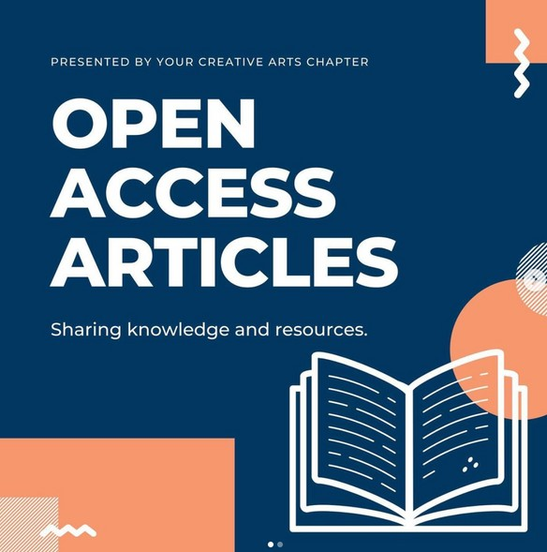
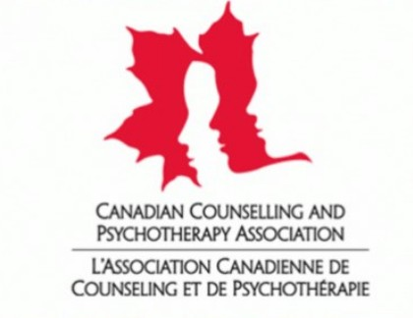
ANNUAL NEWSLETTER PAGE 10

MAY 2021

In conversation with Catie Ajin Jeon, Trina Chakrabarti, Rowena Tam, and Stephen Legari on the CATSOCAAA Speaker Series & Discussions
Annual Newsletter Article Feature
On May 7, 2021, CATSOCAAA President and Speaker Series Organizer Catie Ajin Jeon, Discussion Facilitators Trina Chakrabarti and Rowena Tam, were interviewed by Stephen Legari to delve into their experience with creating, planning, and facilitating the 2020-2021 Creative Arts Therapies Students of Colour and Allies Alliance (“CATSOCAAA”) Speaker Series initiative.

Tell us a bit about yourself, your discipline, and your role within this series.
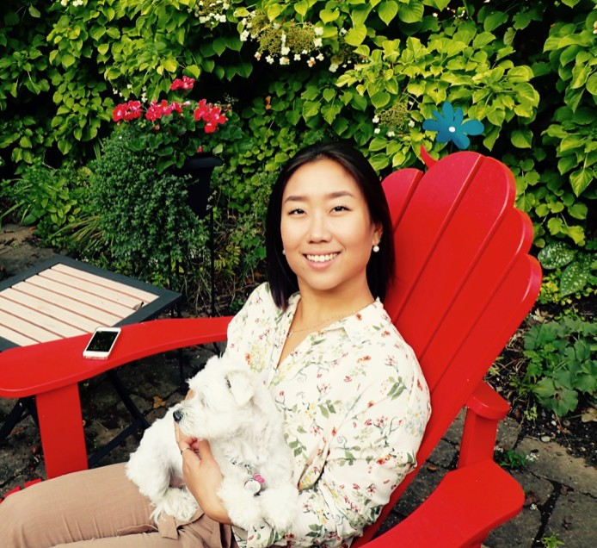
Catie: I just finished the second year of my MA degree in art therapy at Concordia and have my research to finish up during the summer. My role in CATSOCAAA this year was “President.” I giggle when I say that because I don't really know what that means. My role this year involved organizing the Speaker Series that we're talking about today, that Trina and Rowena facilitated. That was my main role - so I held some meetings, got some volunteers to help get some grants and then I sent a lot of emails.
Trina: My name is Trina Chakrabarti. I am a registered music therapist and Master's student at Concordia University. I'm actually graduating in June, but I have completed my thesis. My main career interest is in mental health care and bringing music therapy into spaces that may otherwise not have access. I'm still quite new to the profession, and I will soon be a recent Master’s graduate. During the speaker series I was one of the discussion facilitators for the discussion that followed each of the speaker
events. I helped to lead discussions around what was spoken about in the speaker series,
as well as processing emotions and feelings that came up during them. I am currently living in Toronto, Ontario, and I recently got hired in a virtual music therapy mental health care subcontractor position.
Rowena: Hi everyone, I’m Rowena Tam and I am a researcher, artist, and drama therapist living and working in Tio’tia:ke/Montreal. I graduated from Concordia’s MA in drama
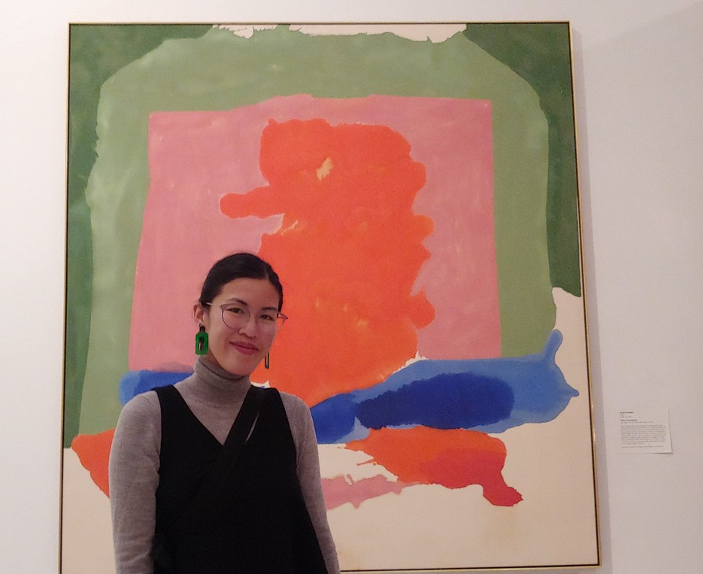
therapy program in 2019 and now work as a strategy and well- being coordinator with the Montreal Indigenous Community NETWORK. I also work in private practice, offering low-income and/or BIPOC community members sliding scale or pro bono drama therapy and counselling. Along with Trina, my role in this series was a co-facilitator for the follow-up discussions that shortly took place after the speaker sessions.

ANNUAL NEWSLETTER PAGE 11

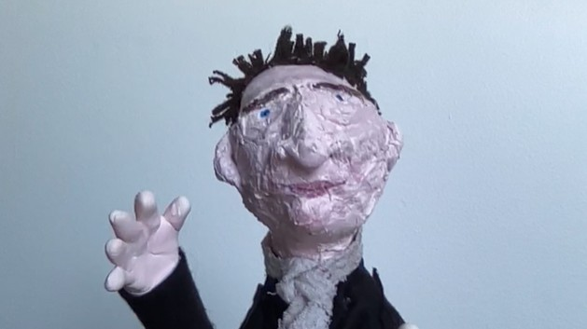
MAY 2021

Stephen: Hello, I’m Stephen Legari. I’m an art therapist and the Program Officer for Art Therapy at the Montreal Museum of Fine Arts. Our program was a partner to the CATSOCAAA series this past year.

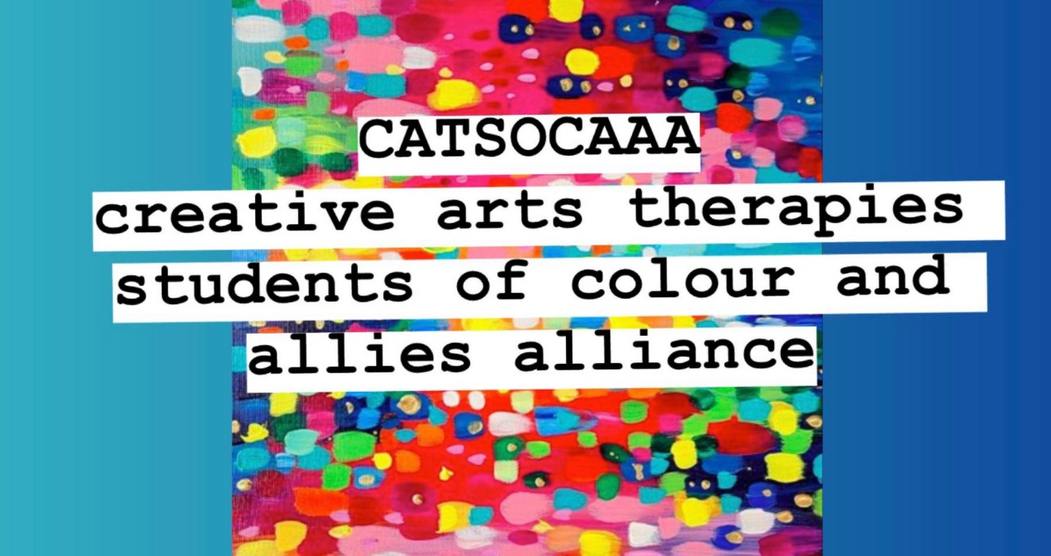
Stephen: What is CATSOCAAA?

Catie: CATSOCAAA is the Creative Arts Therapies Students of Colour and Allies Association. It is a student-run advocacy group for Black, Indigenous, and Students of Colour in the Creative Arts Therapies Program at Concordia University. There isn't really a firm expectation regarding annual events
and it might not look the same every year because the students who run it also vary every
year. The main mandate this year, as well as what it was when it started, was to provide support and safety for the students of colour within the program. The secondary goal this year was to bring awareness to, and facilitate discussions and discourse around the experiences of students of colour within the program, but also bigger conversations around systemic racism, white supremacy, and its continued prevalence not only in our field but in the field of mental health in general. So while the first goal this year was to provide support and safety for the students, there was a secondary goal to start a larger conversation.

Stephen: Last year your CATSOCAAA predecessor Marbella Carlos hosted the first Speaker Session and BIPOC Forum featuring Nisha Sajnani and Savneet Talwar. How did the Speaker Series emerge and why is it important?
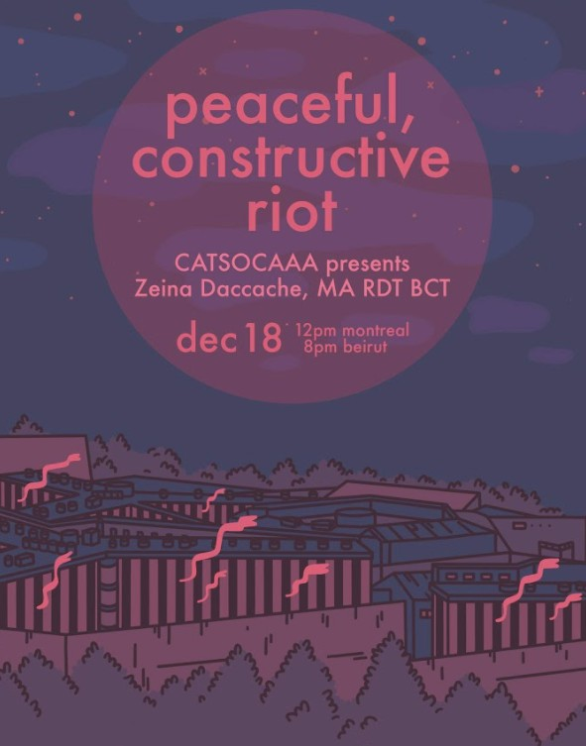
Catie: The speaker series wasn't much of a series when it started the first year because it was never meant to be such a big thing. So when it first started it was a small ambition that was large in practice, if that makes sense. For Marbella as well as for myself, we were students of colour in the program, and we wanted to learn a diverse curriculum that caters to a diverse group of clients taught by a diverse group of professionals. This opportunity wasn't available to us through the program, so when Marbella brought in Nisha and Savneet, I realized we could make available what wasn’t. We essentially just made a space for other students of colour but also for ourselves so we could learn what we wanted to learn from the people who we wanted to learn it from.
Trina: I was at that first Speaker event and honestly it was so wonderful. I don't think I could have truly anticipated how positive of an experience it would be for me. There were two parts, similar to how the current Series has been formatted. There was a main speaker event and, there was a small discussion that in this case was BIPOC closed. I remember going into that discussion and just being able to air out so many things that I wasn't even fully realizing had been on my mind.

ANNUAL NEWSLETTER PAGE 12

MAY 2021

It was just so freeing to be in a space where I didn't have to censor myself. I could really say everything that I was feeling, and bounce back and forth with my POC peers. I could see how they related to my experiences and how I related to their experiences and it was honestly really beautiful. Seeing Nisha and Savneet, I remember wishing that we had more faculty like them at our school. They were so understanding and they held the space so well. It was lovely to see successful brown therapists out there in the creative arts. I had hardly learned or heard about other POC creative arts therapists, so it was an inspiring, and fulfilling experience.

Stephen: What are the Speaker Series and what was your role during the actual live event for the Speaker Series?

Catie: So the speaker series was exactly that - a series of speaker events that were open to the students, alumni, faculty and affiliated professionals within the Creative Arts Therapies Department at Concordia University. There was one speaker event per month from December 2020 to April 2021. Following each event, there was also a follow-up discussion, so from November to April there was one speaker event and one discussion per month. Each speaker event and discussion was an hour long respectively, and all discussions were facilitated by Rowena and Trina, but the speaker and topic for each event was different every month.

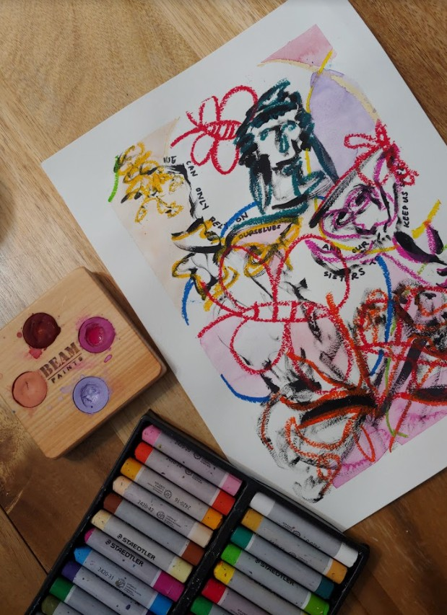
My role within the events themselves actually wasn’t too involved. I essentially made the meetings for each event because they were held virtually. At the beginning of each event, I introduced the speaker and our grants. I also spent a few minutes in every event going over ‒ I was going to say land acknowledgement but it wasn't just about the land acknowledgement. It was about what it means to be having these events on stolen lands. And my goal in doing that in every event was to really have a discussion that extends past land acknowledgements that are written for each university in Canada. So the discussion changed as my own knowledge and learning changed with each event.

Artistic reflection by Rowena
So that was my role in each event. The whole thing was online so we were able to invite speakers from various countries, not just Canada. We had Zeina Daccache from Lebanon who joined us from Beirut,

and we had Leah Gipson from Chicago who joined us, and the attendees were able to also join from anywhere in the world. I think that was one of the perks of having these events online because we were able to reach people in different locations that we may not have been able to reach otherwise.

Stephen: Who was featured in this Speaker Series and how were they selected?

Catie: The speakers were selected through discussions with other people, to be honest. Because I was running the series primarily on my own, I really just took suggestions from the peers that

ANNUAL NEWSLETTER PAGE 13

MAY 2021

I had around me. I consulted the CATSOCAAA team where it was put up to a vote but really the response that I received was overwhelmingly supportive for any of the names that were listed. I think that speaks to how badly students want to see more diversity within the field and program. A lot of people sent in suggestions so then I went through the names and looked at their modalities, the kind of work they have done, and the topics they have researched to ensure we didn't have two very similar topics selected.
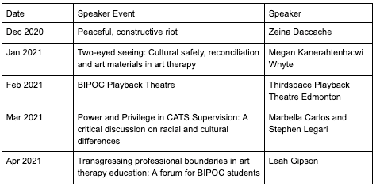

Stephen: What was it like to be approached to be a facilitator for the discussions? What did you notice was the function that this was serving?

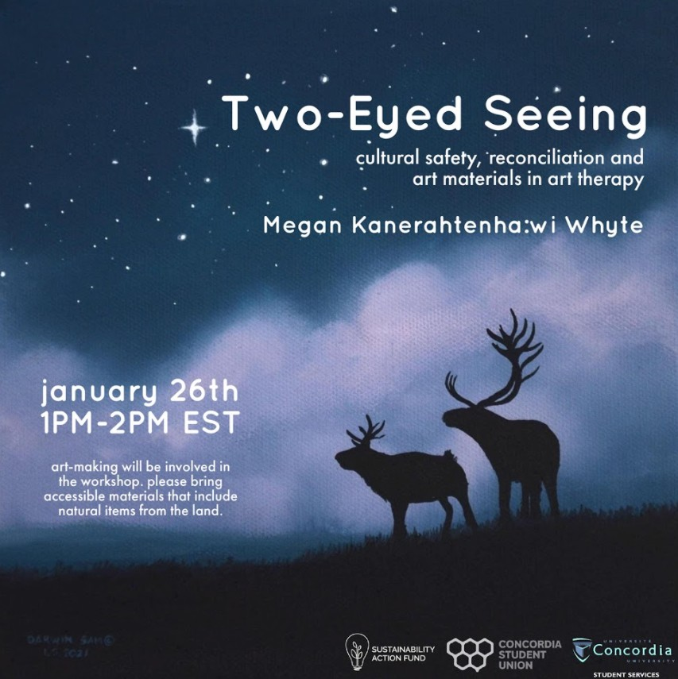
Rowena: I was pleasantly surprised and humbled and honoured. As a recent alumni who works with minoritized communities doing drama therapy, I felt really keen and driven into making time for this initiative. The discussions felt very intimate, you know? The speaker sessions were more formal where there's a presenter sharing about a specific topic whereas, I felt like as a facilitator for the discussions, I got to honour the reflections and stories that people held onto post-speaker sessions and wanted to expand on. Conversations that we ourselves may have internalized or not have had the chance to bring to the surface because of the formalized environment of the speaker events. The discussions functioned as a space where people could casually talk, connect, debrief, ask questions, and make art about anything. We offered a space for students to be imaginative and explore ways that we could build a safer future together in the field of creative arts therapies.

Stephen: Trina, you were not only co-facilitating the discussions, but you were also an attendee at each of the events. Can you describe what it was like to
p lay those two roles? And how did being there formulate some of the holding that you would do or some of the questions you would bring to the discussion?

Trina: I think I really value the fact that I both attended the speaker event, and co-facilitated the discussions. I was able to understand not

Poster created by Darwin Sam
Cree artist from Chisasibi -- @the.torn.prince

ANNUAL NEWSLETTER PAGE 14

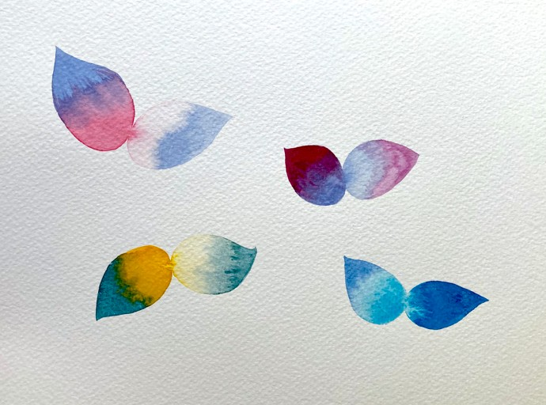MAY 2021

only the questions that were asked by participants, but also understand where the speaker was coming from and what they were speaking to in its entirety. I think by going to the speaker events it really helped me to establish themes that I could bring up later in the discussion. It helped me to hone in on certain questions and comments that people showed interest in and wanted to talk about. I think in general it also just helped me hold the discussion space better because I had a bit of an idea going into it what people might want to

Artistic reflection by Catie
process. The thing about a series like this is a lot of the processing is going to happen over time and the discussion was great for that because it gave each of the participants some time away after the speaker to think about their experience, and then come back. At the same time it was under the acknowledgement that people might have to process what they've learned and what emotions came up far after the discussion Series is finished. Going to both sections of the series helped bridge the gap of understanding what

participants might want to talk about, and communicate that as a discussion facilitator I'm also learning and I'm just as much of a participant. I still have so much work to do myself which I think can be really validating for people when having these kinds of conversations. I think that it can be complicated at times to play dual roles but in this situation it was really beneficial for me.

Stephen: Catie, why would you approach an art therapy program at a fine arts museum to be a partner on this? What connection did CATSOCAAA have with the Montreal Museum of Fine Arts (MMFA)?

Catie: To be honest, in my head when I approached the MMFA, I was approaching Stephen and less so the museum if that makes any sense. I think my partnership with your art therapy program at the Museum was great. But I also think museums have been a very contentious place for a lot of marginalized groups and artists whose artworks are often stolen, often appropriated, or erased. Museums are very privileged spaces and a lot of people have been erased throughout our history in galleries and museums. I bring this in because I think this is important to highlight and I was also keeping this in mind when approaching the museum.
Then there's the very real practical side where a partnership with the museum helped greatly in securing grants and funding while allowing a bigger platform to make an impact within the system. It also allowed access to spaces for events (this was when I was unsure whether it would be online or in person) as well as art collections, which were great resources. It also added a level of legitimacy to the events being run and we got the attention of a lot of institutions and funding bodies that we wouldn’t otherwise have gotten to make this possible. But in going back to my worries about the museums - I don't think those benefits would have been enough for me to reach out for a partnership had I not been confident that I could work with the person that I would be working with ‒ who was Stephen. So I guess the very simple

ANNUAL NEWSLETTER PAGE 15

MAY 2021

answer to: “Why did I reach out to the museum as an institution?” ‒ for the very practical benefits and resources such as art collections and securing funding. “Why did I reach out to Stephen?” Because I thought we would work well together.

Rowena: Stephen, how did you select and weave the MMFA’s artwork into this series?

Stephen: In all our partnerships we explore ways to use the museum’s collection as a focal point for discussion, connection, and reflection. Throughout the series I created a virtual gallery of BIPOC contemporary artists that are a part of our permanent collection or featured in exhibitions. It was my ambition that these artists would not only serve as a source of inspiration to those attending the series but also as companions during the moments of necessary reflection that this series invited everyone to do. In the spirit of transparency, I chose a number of the artists based on my own love of their work. But to be sure there were artists who have achieved remarkable heights like Kehinde Wiley. In other choices, beyond just brilliant aesthetics, it was the opportunity to enter or imagine a narrative such as the works by Radcliffe Bailey or Mickalene Thomas. The use of the fine arts in art therapy is relatively new in art therapy but the use of projective or aesthetic containment have long histories in the creative arts therapies. For me, the artists in this virtual gallery are the embodiment of excellence. Their work can be gathered around, basked in, and learned from.**

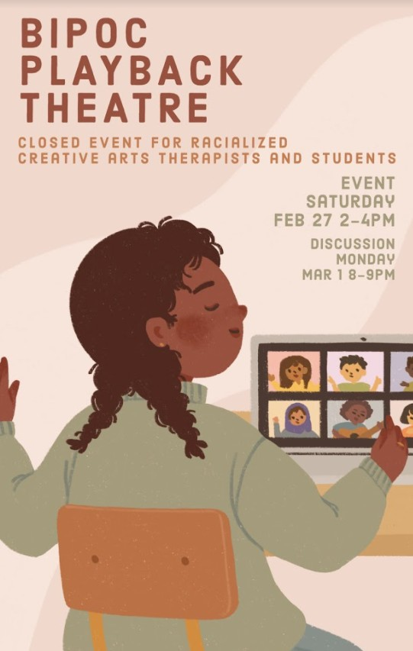
Stephen: Following each event, you and Trina would co-facilitate the follow-up to the attendees of the Speaker Sessions. Trina spoke to the bridging of the events. Rowena, you encouraged people to be, if they chose, creative during the discussions. Can you talk a little about that?

Rowena: Seeing that the space was filled with creative arts therapists, students and alumni, we encouraged participants in the discussions to really engage in processing in creative ways. We provided people the opportunity to externalize their internal thoughts whether it was through art-making or through a collective conversational banter.
Participants did not necessarily need to engage by talking and could just process through listening and processing what's being said through doodling, journalling, and painting.

Stephen: We’re coming to the end of the Speaker Series. When you look back on it and see the results
of what was a tremendous amount of work, what do you see? What do you feel about the
series? What would you like to see happen next?

Catie: What do I feel about the series? First and foremost I feel incredibly humbled by the people that I got to meet, including the speakers for sure, but also you guys, and even my peers that I got to work with that I'd never gotten to work with before.

ANNUAL NEWSLETTER PAGE 16

MAY 2021

That's what's been extremely valuable for me and what is sticking with me. That being said, it was exhausting. Exhausting to the point where I haven't even really had the time or energy to reflect on it since our last event. I think my feelings around it will change and I think different feelings will surface as I continue to reflect on it more. Although I'm not sure what those feelings are now, I think probably some regret is going to come up on how I could have done better, probably some anger about why it was so exhausting, and probably some frustration as to why this had to be a student-led initiative versus something that is already incorporated into our education. There is also just a lot of gratitude and inspiration towards the people that I was blessed to work with and to invite. I think it's going to be a mix of all of those emotions.

Stephen: What feelings are you left with as you reflect back on the virtual space and what would you like the person or persons taking on this role next to know?

Trina: So regarding your first question, in the beginning I thought “Am I even qualified to take on a role like this?” As someone who is so new to the field, I worried that someone else would be able to provide a better experience for students. However, having my peers believe in me was heartwarming, and helped me gain confidence. Seeing fellow BIPOC creative arts therapists value and uplift each other was so lovely and something that I will value for a long time. And oh my gosh, just hearing the speakers! I wish during my education I had so many more events like these. It was something that I wanted but was never able to articulate. This series physically put that out there. I felt that this is what I’d been missing. I was so inspired by all these incredible BIPOC therapists all around the world doing such amazing work and I felt grateful getting to hear them and work with them. With the Discussion Facilitation itself, I think we get back to that emotion of freeing because in a lot of the discussions, participants really didn’t hold back. People said what was on their mind, and we made an effort for them to know that things were confidential. Students by no means had to share what they didn’t want to, however nothing was off the table. It was really wonderful to see. Even though we didn’t really have any faculty at the discussions, in a way it made students feel safer to say what they wanted, and say what was on their mind. There’s a power dynamic with faculty members. Students will be naturally worried about any repercussions to speaking their mind.
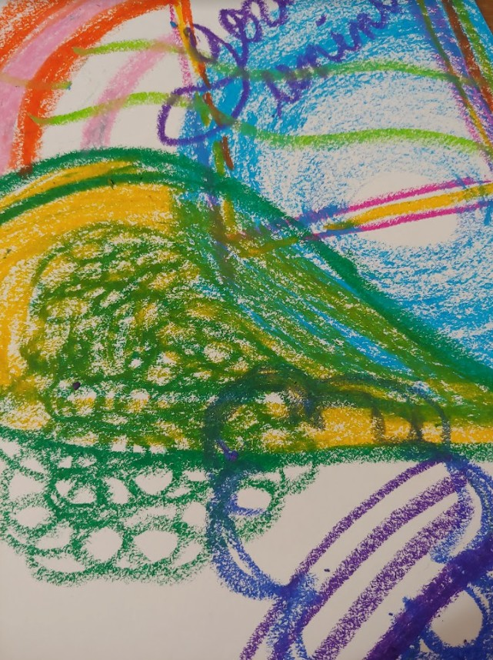
However, at the same time it was disheartening to see that very few faculty members were at the speaker events. There was only one speaker event with multiple faculty members. It was really rare to faculty at the speaker events, with the exception of Stephen. In our own education, we’re always told to seek out continuing education, and students are doing that and putting in the effort. So seeing a lack of faculty at the speaker sessions was disappointing. As Catie said earlier, this was a student-run event that should have already been in place. To have a student-run event with no faculty show up was frustrating. At the end of the day I am still so grateful for the people I have met through this experience.

Artistic reflection by Rowena
To anyone that comes into this role in the future I want them to know that they've been chosen for a

ANNUAL NEWSLETTER PAGE 17

MAY 2021

reason and they're there because people want to hear what they have to say. They're there because they can hold a space. They're there because people will potentially feel very safe and secure in that space to express the things they need to feel. I think it's important to acknowledge that going into the series, if you are a future facilitator you're there for a reason and your role is important. It's also important for future facilitators to know that you will also experience complicated emotions. We bring up processing to the participants and how it's an ongoing experience. It's important to acknowledge that it's also an ongoing experience to the facilitators, and to anyone who's involved in organizing. It's important to recognize that you deserve processing and you deserve the right to do that in whatever way you need to. At the end of the day make sure to allow yourself the patience that you're allowing the participants in the speaker series to have.

Stephen: As we see in the name CATSOCAAA, this series was open to Black, Indigenous and creative arts therapists of colour and allies, both in-training and those already in the
p rofession. These can be complex. What did you notice in bringing this complexity to the table?

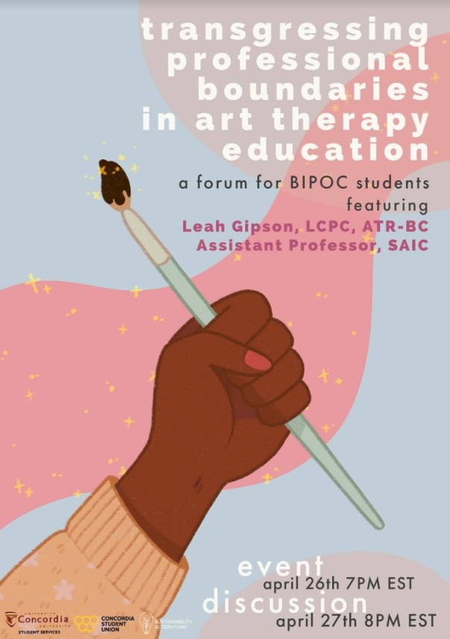
Rowena: Great question. I want to bring up Leah Gipson, who was our most recent speaker who created an opportunity and space where BIPOC were at the forefront for her presentation. Like, yes this is open to everyone just like CATSOCAAA is, and how the series is, but we want to prioritize comments, questions, and thoughts from BIPOC folks. At the very beginning, Catie, Trina and I talked about how we didn’t want white tears, white guilt and defensiveness to consume the space and thought about ways to navigate this. We were worried because ultimately those that are put at harm and are most likely to be harmed, even in a series such as this, are the minoritized.

As an alumni working in the professional field, I met students of colour who I had never met before. I learned a lot about their stories and overlapping experiences that I wouldn't have otherwise heard had this speaker series and
discussion portion not existed. Although I saw a lot of learning and unlearning from students
and professionals alike occur within our virtual discussion space, I do believe that there were things that we could have done to encourage more. And you know, despite me saying how we didn't want whiteness to be infiltrated - it's indoctrinated so really it's impossible to separate the two. Additionally, even the term “allies” I sometimes have an issue with because we forget that it's actually a verb and so it’s so easy to call ourselves “allies” just for showing up to an event without actually doing the work ‒ as modelled to the students by many of the faculty in this department.

ANNUAL NEWSLETTER PAGE 18

MAY 2021

Stephen: It’s 2023. What has happened to all of your hard work? What do you want to see happen to the CATSOCAAA and the future of this series?

Catie: I want it to be a thing of the past. I want all of my labour, and the disproportionate efforts of BIPOC students to be a thing of the past. I want it to not exist in 2023, and what I mean by that is, I want to see these initiatives led by the department and professionals within the field of Creative Arts Therapies, rather than by students of colour who are paying for an education and having to stretch themselves thinner to create these opportunities for not only themselves but other students of colour. In my dream world, CATSOCAAA doesn’t need to exist because people of colour are so well-supported, and well-represented within the CATS program, the curriculum, and the field as a whole. Do I think that will happen by 2023? No, not in the slightest. This is my dream world, but what do I think will happen by 2023? I think that really depends on the department, the faculty, and the professionals. I'm not sure what that's going to look like in 2023 because the ball is in their court. I think how much CATSOCAAA is going to have to do in 2023 - involuntarily or voluntarily - is going to depend on how much the faculty is willing to take on, how much effort they're willing to give, and how much change they're willing to bring to the department, the program, and the field.
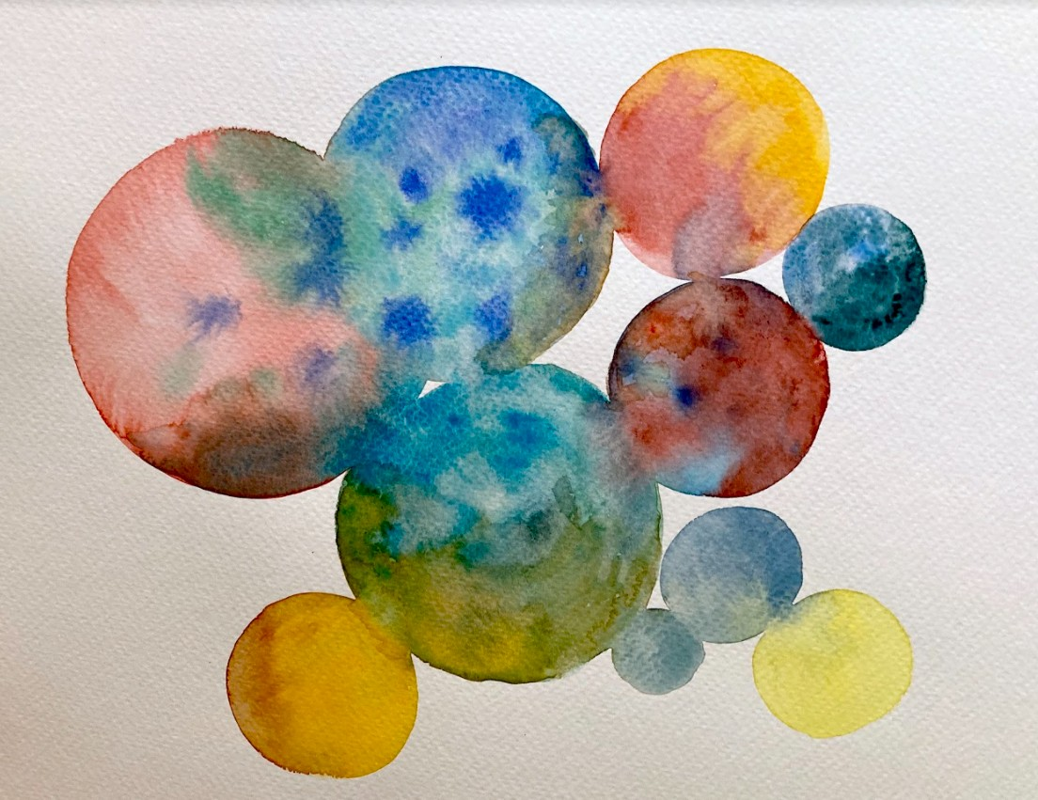
Artistic reflection by Catie

To learn more about Concordia’s Creative Arts Therapies Students of Colour and Allies Alliance (CATSOCAAA) and their Speaker Series, you can visit their Facebook Page or contact them at catsocaaa@gmail.com.
**A sample of featured artworks from the permanent collection of the Montreal Museum of Fine Arts
https://www.mbam.qc.ca/en/works/62185/ https://www.mbam.qc.ca/en/works/71403/ https://www.mbam.qc.ca/en/works/35482/ https://www.mbam.qc.ca/en/works/78475/ https://www.mbam.qc.ca/en/works/79623/ https://www.mbam.qc.ca/en/works/75836/ https://www.mbam.qc.ca/en/works/76581/
All graphic material/posters from the events were created by Sarah Gysin @lilsproutgarden
on instagram

ANNUAL NEWSLETTER PAGE 19

MAY 2021

An Update from our
Student Representative
CONGRATULATIONS to all students on finishing the Spring semester! We can all agree that learning in the midst of a pandemic has brought many challenges. However, it has been inspiring to watch fellow creative arts therapies students persevere and continue doing the great work that they do.
The CACP Chapter sees you and the work you continue to do. We are planning some exciting events for Fall 2021, including self-care workshops and information nights. But we would love to hear from you too! As students, what would you like to see from the CACP Chapter? How can we support you as creative arts therapies students?
Feel free to get in touch with us either through Facebook, Instagr am or by email (cac.chapter@gmail.com).
Thank you and see you in the Fall! Creatively yours,
Lorelei Dietz
Student Representative, CACP Chapter
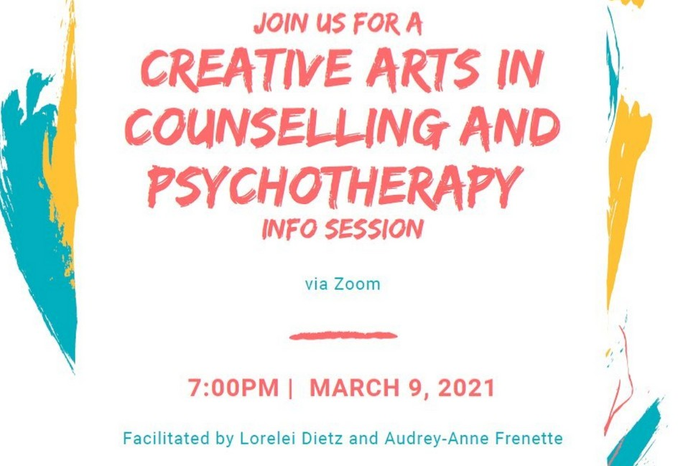
Music Therapy Graduate Student (Concordia University)

Student Info Night
March 9th, 2021
Hosted by Lorelei Dietz, Student Rep & Audrey-Anne Frenette, Treasurer

On March 9th 2021, Lorelei and Audrey-Anne hosted a Canada-wide information session for students in the creative arts therapies. Eighteen lovely people join us, a mix of current and prospective creative arts therapies students. Students learned about the CCPA and CACP Chapter activities, as well as opportunities for future involvement. All attendees were presented with a 5$ Starbucks gift-card for participating. A big thank you to all students that attended, we hoped you were able to enjoy a drink on us!
Upcoming Opportunities for Students

We will be looking for a new Student Representative in the fall, so keep an eye on our Facebook and Instagram for more information on that and other upcoming events. Coming to you in Fall 2021!

ANNUAL NEWSLETTER PAGE 20

MAY 2021

Get involved with the
CACP Chapter!
Vacant Position!
COMMUNICATIONS DIRECTOR
We are seeking someone to fill the position of Communications Director! We are looking for someone social media savy, that is (or is willing to become) a chapter member, and is passionate about fostering connection and community amongst
Creative Arts Therapists.
Those interested should send their name, creative arts modality (i.e art, music, drama, etc.), and CV to cac.chapter@gmail.com

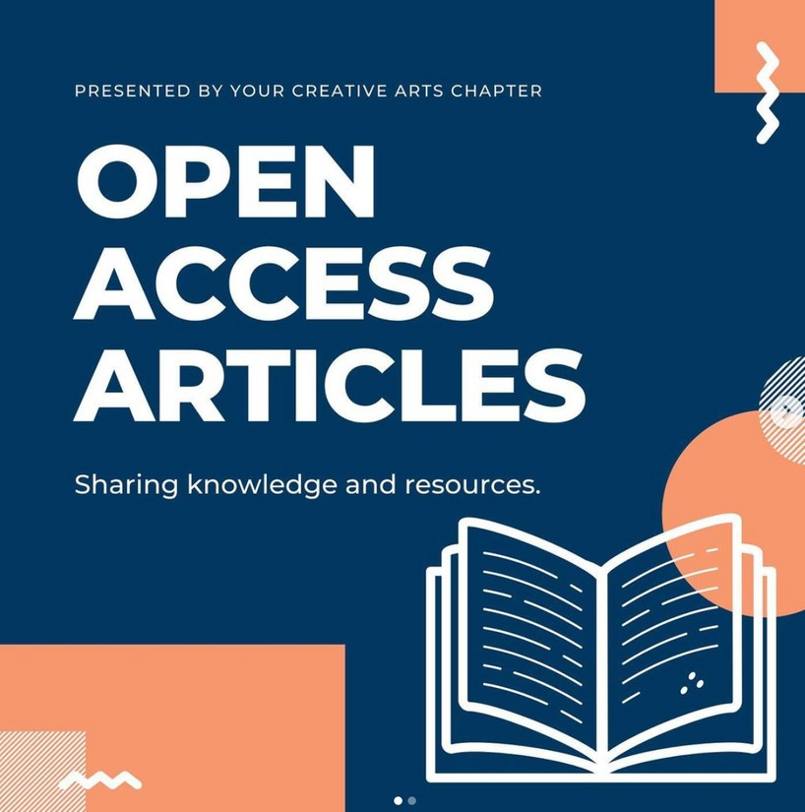
CACP Journal Club
We know that accessing research can be difficult. Each Monday, we share research articles from the Creative Arts Therapies and make them available to you on our Facebook and Instagram pages.
Know of any research articles worth sharing? Send us an email at cac.chapter@gmail.com!

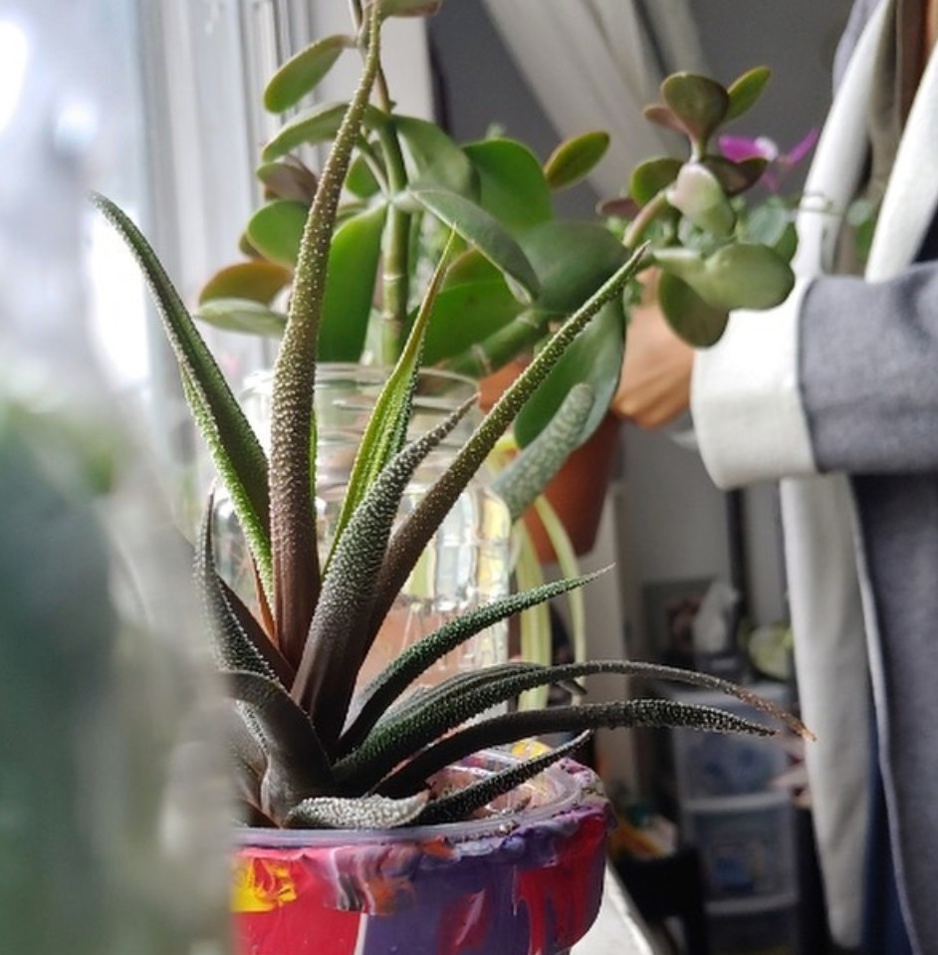
Self-Care Sundays!
It's safe to say that throughout 2020 and 2021, self- care has become more important than ever. To raise awareness and continue the discussion on the importance of self-care, we began Self-Care Sundays! Each Sunday, check out our Facebook and Instagram pages to see how CACP Chapter members make room for their self-care.
We always love hearing from you, our members! If you would like to share your self-care practices, let us know by emailing cac.chapter@gmail.com

ANNUAL NEWSLETTER PAGE 21

MAY 2021

Resource Lists for You!
In the Spring of 2020, when COVID-19 began to change the way people worked and lived, we decided to begin compiling resources for Creative Arts Therapists. The COVID-19 Resource List is a compilation of articles, research, and interventions about the Creative Arts Therapies and changes in practice due to COVID-19. We have also included numerous mental-health resources because self-care is now more important than ever. This resource list is what we call a “living document,” meaning we update and add to it daily. We, the CACP, hope that this list proves helpful and as always, we encourage you to contact us at cac.chapter@gmail.com with any resources that should be added to the list.
Access the resource list here!

The CCPA has also created a fantastic COVID-19 Resource List for their members that can be found here!

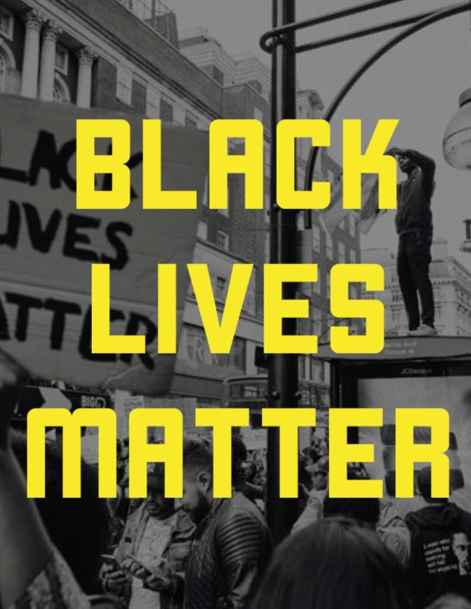
Our Black Lives Matter Resource List is a compilation of articles, interventions, and essays within the Creative Arts Therapies. Our goal with this list is to amplify BIPOC (Black, Indigenous, People of Colour) therapists and artists, as well as to provide resources for educating, reflecting, and putting into practice ways of dismantling racism within our field.
We have also included numerous mental health resources and links to additional readings by BIPOC authors. This resource list is what we call a “living document,” meaning we update and add to it daily. We, the CACP Chapter, hope that this list proves helpful and as always, we encourage you to contact us (see below) with any resources that should be added to the list.
Access the resource list here!

ANNUAL NEWSLETTER PAGE 22

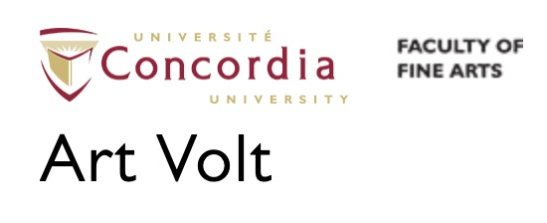MAY 2021
Upcoming
EVENTS

& OPPORTUNITIES
Concordia University's Art Volt is happy to announce a new residency program designed specifically to help support recent alumni of the Creative Arts Therapies program by providing them opportunities within Montreal based organizations. To this end, we are thrilled to collaborate with the Alzheimer Groupe, the Jewish General Department of

Click here to learn more.
Child Psychiatry and the Pointe-Saint-Charles Art School at Bâtiment 7.

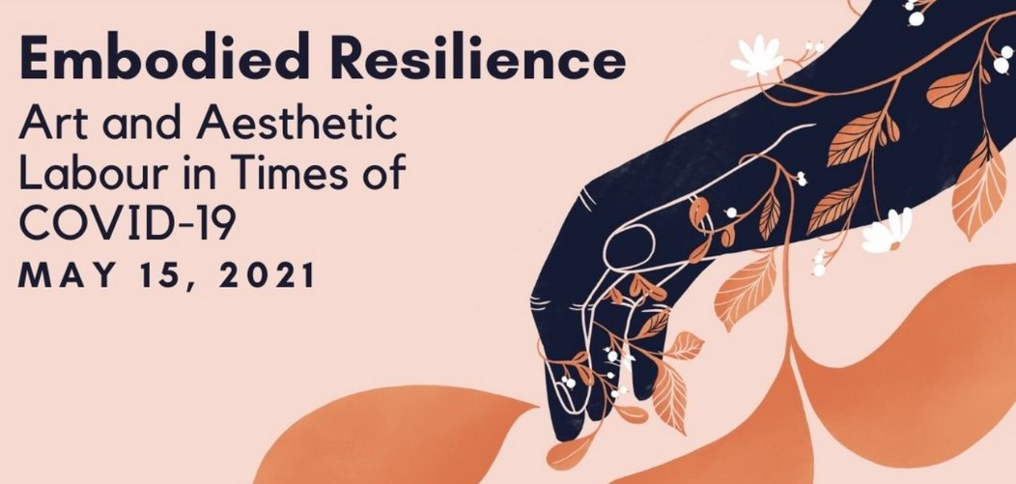
“Embodied Resilience: Art and Aesthetic Labour in Times of COVID-19” forefronts aesthetic production by Queer, Trans, Black, Indigenous, and People of Colour (QTBIPoC) artists during times of ongoing, colliding struggles and pandemics. This multidisciplinary showcase will bring together local GTA artists in drag, burlesque, spoken-word, poetry, film, and music production. More info about how to participate can be found on their Facebook event!
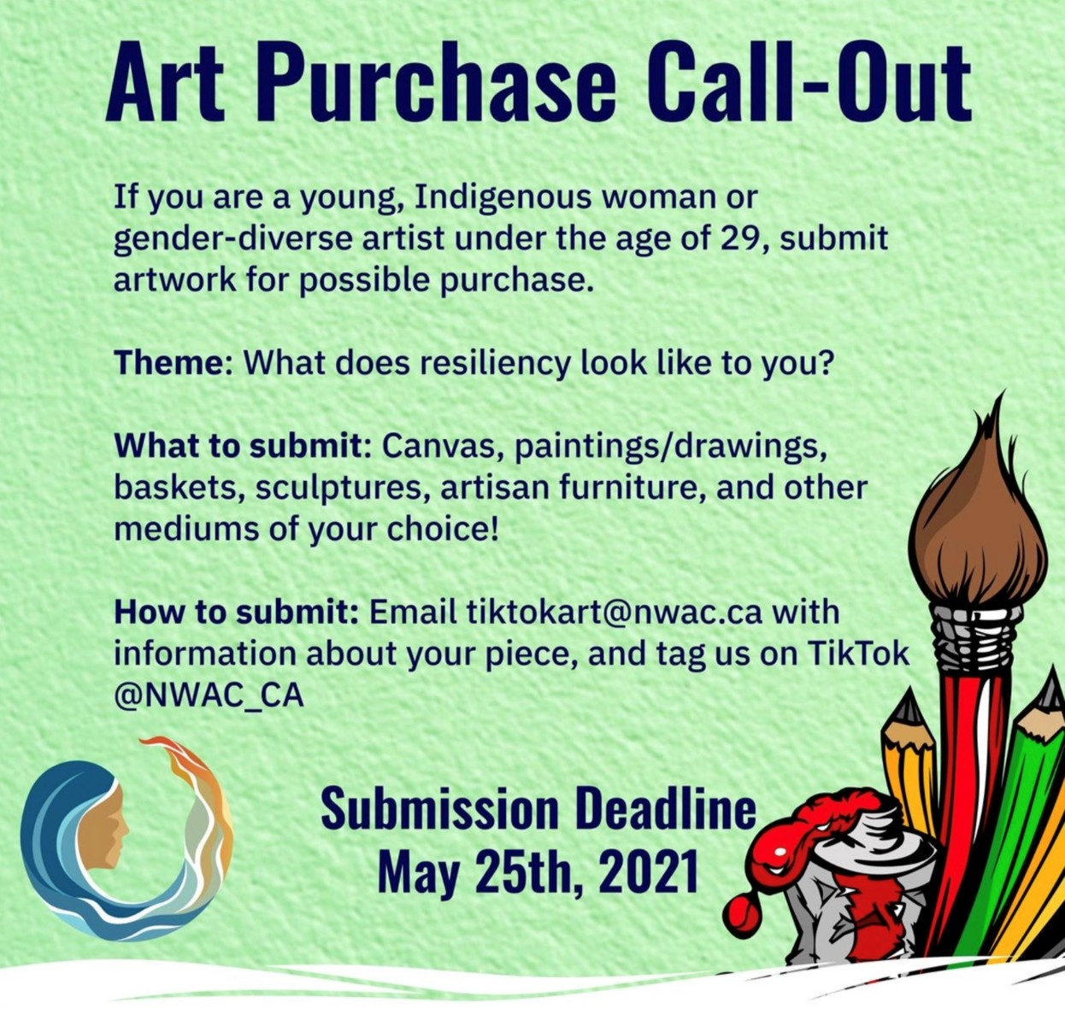
The Canadian Art Therapy Association Journal has extended the deadline for submissions! The Journal's theme? Art Therapy Education: Research and Reflections from the Field invites submission of articles that explore art therapy education that advances the field forward in both contemporary Canada and international spheres.
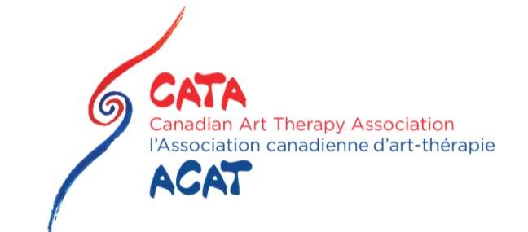
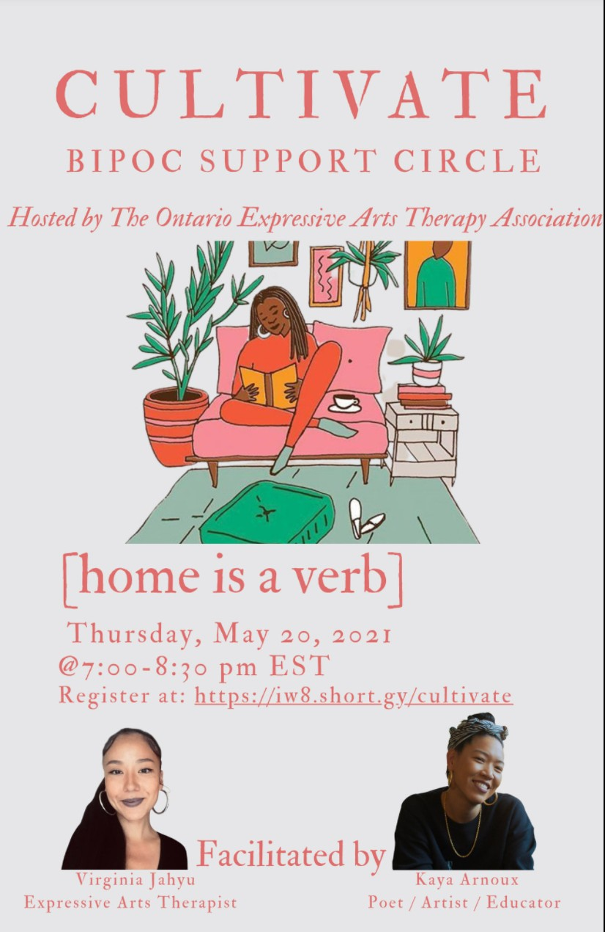
The deadline has been extended to June 15th, 2021!

ANNUAL NEWSLETTER PAGE 23

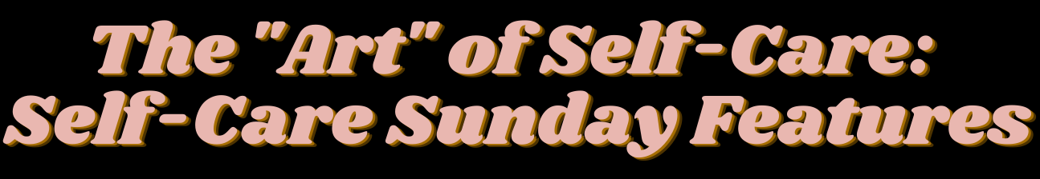

Self-Care Sunday’s @selfcareisapriority be kind to yourself ( @lucialitman ) #mentalhealth
To Rowena Tam, dim sum is a warm and hearty love language shared by her family, and an important Sunday brunch tradition.
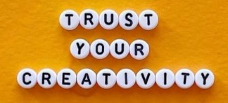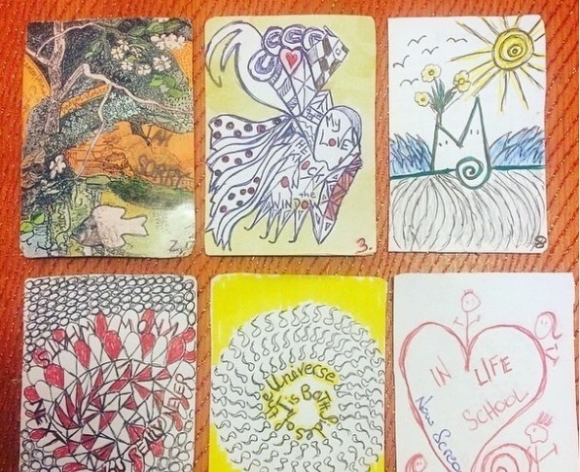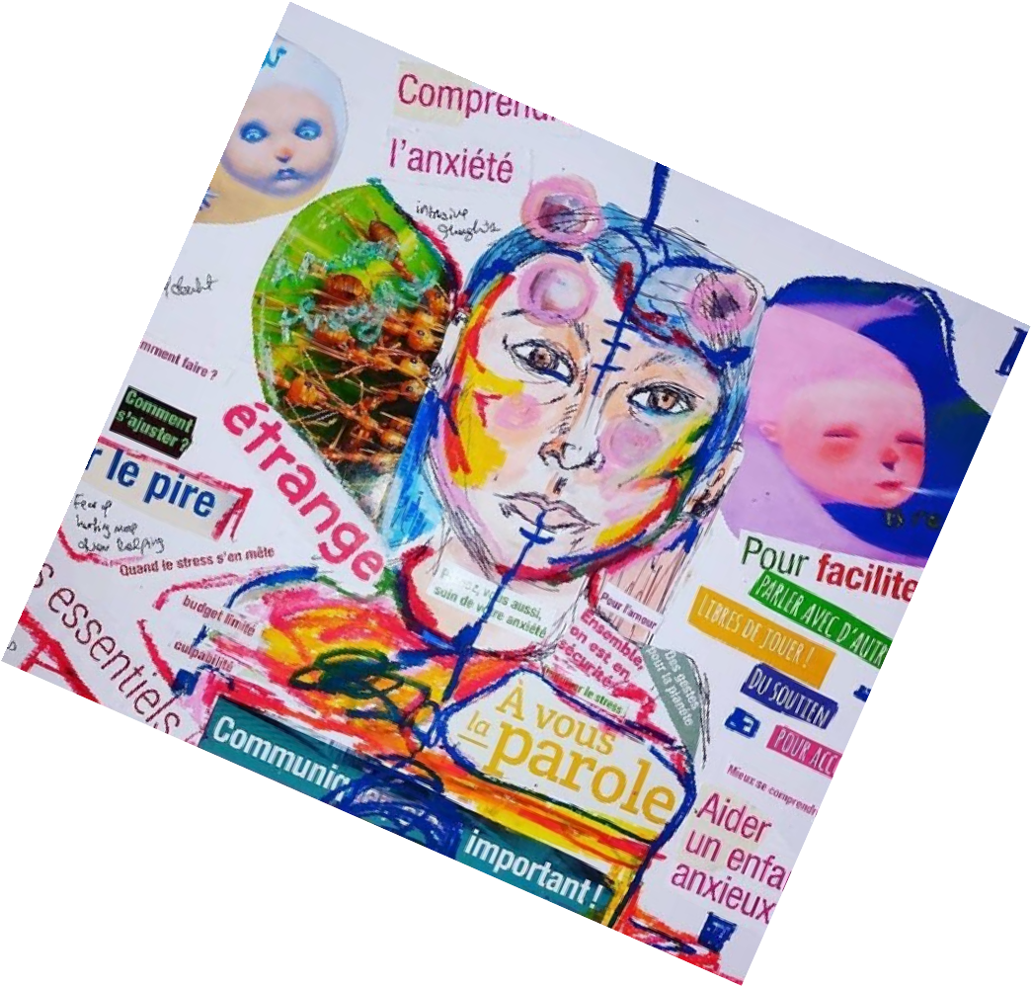Fun fact: dim sum (點⼼) translates to
"touching the heart" photo from Rowena @helloimrow

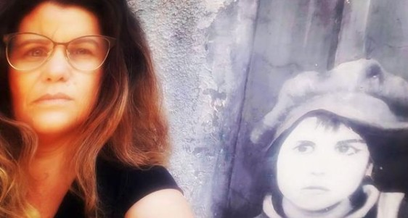
Part of my self-care practice is the creation of "Emotional Trading Cards“ (ETC) It’s a daily five to ten minute check in, a mini respite, using old playing cards. Photo submitted by Margit @play_therapy_w_margit
“I do a daily watercolour and ink journal entry using imagery and symbolism to create intention and integrate my thoughts, feelings, sense of intimate self and connection to others. I chose a pair of underwear to represent my present state in a given day because it is a readily recognizable symbol of intimacy and because it can evoke a diverse range of feelings and reactions."
Self-Care post by Andrea @andreacooketherapie parlesarts

"“Taking a moment between or after sessions to reflect and explore how i feel, through self portraits photography. photography helps me process and detox issues that come up in therapy sessions.”
Photo submitted by Sharon Shelly @tishko1

https://www.ccpa-accp.ca/chapters/creative-arts-counselling/ https://www.facebook.com/ccpacreativeartschapter https://www.instagram.com/creativeartschapter/

