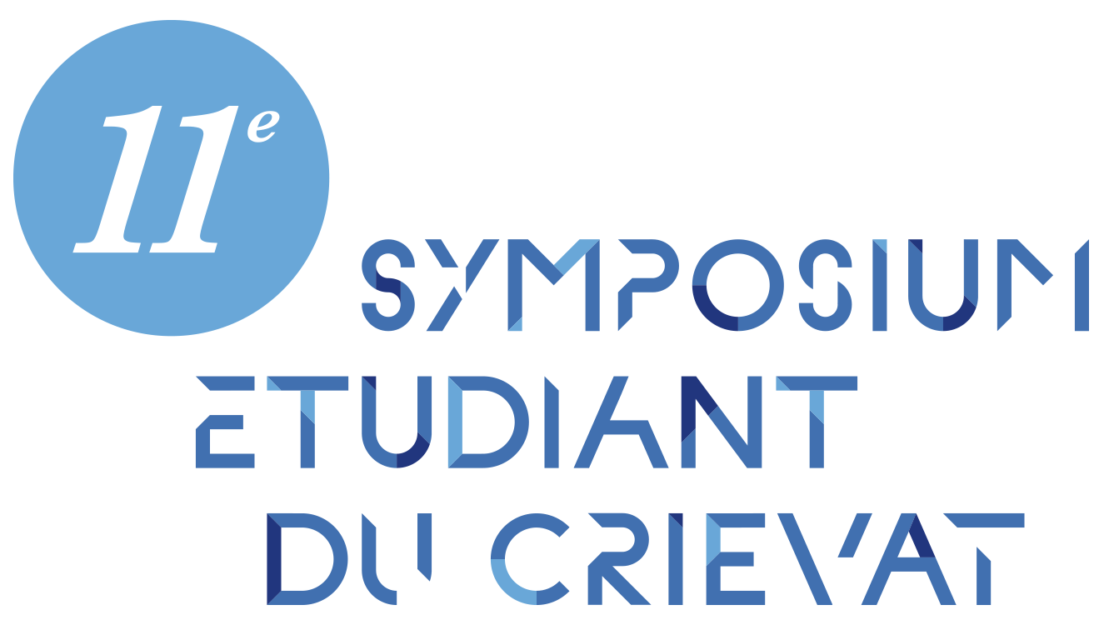 | Organized in conjunction with:  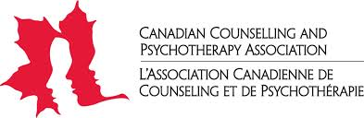  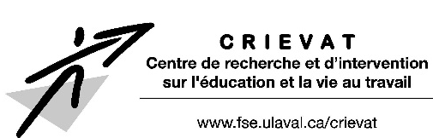

SHARING OUR KNOWLEDGE AND PRACTICES FOR LIVING BETTER IN SOCIETY

March 23, 2018 at Université Laval (Quebec City)

Call for Presentations
December 15, 2017: Deadline for Proposals

We are delighted to announce the 11th annual CRIEVAT Symposium on the theme of Sharing Our Knowledge and Practices for Living Better in Society. This year’s event will be bilingual and has been organized in conjunction with the Canadian Counselling and Psychotherapy Association (CCPA). Open to the French- and English-speaking university community, it will focus on:

- Life skills, transitions, personal/educational experiences
  - Career choices / Educational programs / Socio-economic integration / Finding and keeping a job / etc.

- Different life/occupational trajectories
  - Considering different spheres of life / Psychological wellbeing / Psycho-social development / Integration-reintegration / etc.

- Developing individual and collective support practices
  - Sociocultural and occupational diversity / Intervention strategies / Preparing and implementing interventions / Analysis and transformation of practices / etc.

This relaxed setting will serve as an interdisciplinary exchange on projects of master’s and doctoral students, as well as of students in education, social sciences and the humanities (sociology, guidance, counseling, psychology, administration, industrial relations, etc.), whatever the progress of the work (literature review, issue, methodology, research results). Presentations may take one of two forms:

Oral (in French or English):
20 minutes will be allowed for each presentation, plus a question and answer period with the audience.

Poster (in French or English):
Poster presentations will be scheduled throughout the symposium.

For the oral presentations, there will be a possibility to be published in INITIO (www.initio.fse.ulaval.ca/), a student scientific journal (for articles provided in French). A jury will also award prizes for the best presentations.

New this year is a bilingual symposium. This means you can submit your presentation in French or English. Simultaneous interpretation will be provided.

Please email your abstract of up to 25 lines to FORMULAIRE D’APPEL À COMMUNICATIONS by December 15, 2017 at: symposium.crievat@fse.ulaval.ca

Proposals will be reviewed by a scientific committee consisting of undergraduate and graduate students. Replies to your proposals will be sent by late January 2018.

Registration will be free for presenters and accommodations will be offered to those living outside the Quebec City area.

INFORMATION: SYMPOSIUM.CRIEVAT@FSE.ULAVAL.CA

