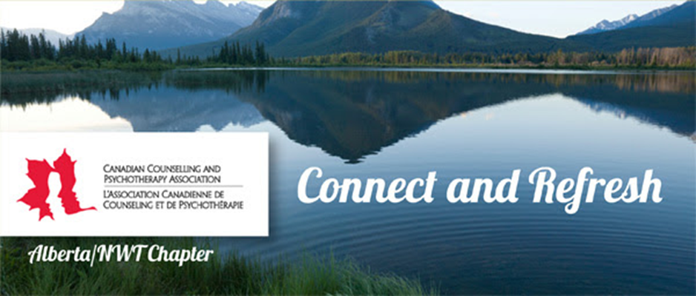
Canadian Counselling & Psychotherapy Association, AB/NWT Chapter
Northern Lights Award Application/Nomination
Type or print all information
Name: ___________________________________________________ CCPA#:_________________
Home Address: ___________________________________________________________________
City: _________________________________________ Postal Code: ________________________
Email: ___________________________________Telephone No: ____________________________
Professional Credentials: ______________________________ ______________________________
Current Employer & Employment Address: ______________________________________________
Referee’s Name: _______________________________________________
Nominee’s name if different than above: ________________________________________________

• I declare all information provided by me in this application to be true and agree to abide by the Terms of Reference of this Award if my nomination is approved.
• Freedom of Information and Protection of Privacy Notice: The information on this form and all supporting documents is collected under the authority of the AB/NWT Chapter of the CCPA. The information is needed to adjudicate the Distinguished Service Award competition and will be used to determine the most suitable candidate for the Award. (If you have any questions about the collection and use of this information, please contact Velma Noble via member-at-large@abnwtchapter.ca
Applicant Signature & Date___________________________________________________________
Canadian Counselling & Psychotherapy Association, AB/NWT Chapter
Northern Lights Award Application/Nomination (page 2)
Please provide one single-spaced, typed page (1.5’’ margins, 12 point font) describing your (nominee’s) contribution to the counselling profession in the Northwest Territories in the year prior to this application, in a community, university, practicum or other relevant setting. (Examples of such contributions include active volunteer involvement or representation in counselling-related initiatives, events, projects or programs. Your description should mention all past and present engagements and responsibilities, as well as any other volunteer award(s) held.) This Nomination/Application must be sent directly to member-at-large@abnwtchapter.ca using the subject line: northern_lights_reference_the_name (of nominee).

Please also provide the name of the person chosen as the referee. This person must complete the attached Referee Form and a confidential reference letter in support of your application and submit these directly to member-at-large@abnwtchapter.ca using the subject line: northern_lights_reference_the_name (of nominee).

In order for the candidate to be considered, all documentation must be completed in full and be received no later than midnight August 12th, 2016. Award winners will be announced at the Research conference and AGM, October 15th, 2016. For more information visit: https://www.ccpa-accp.ca/2016-research-conference/
Canadian Counselling & Psychotherapy Association, AB/NWT Chapter
Northern Lights Award-Referee Form
To Referee: Please complete this form, and prepare a confidential reference letter in which you comment on the applicant’s demonstration of the following:
• Contribution to the counselling profession in Northwest Territories in the years prior to his/her application, in a community, university, practicum or other relevant setting. (Examples of such contributions include active volunteer involvement or representation in counselling-related initiatives, events, projects or programs.)
• Participation in the AB/NWT Chapter, CCPA (if relevant to nominee’s application).
Name of Applicant: ___________________________________________________________
I have known the applicant for ____ years, in my capacity as__________________________.
Name of Referee ______________________________ CCPA member: N___ Y___#______
Agency/Institution ___________________________________
Position ___________________________________________
Signature of Referee _________________________________
Date ______________________________________________
Both the completed form and reference letter must be emailed directly to member-at-large@abnwtchapter.ca by the author using subject line: northern_lights_reference_the_name (of nominee) no later than August 12, 2016. No late applications will be considered.

