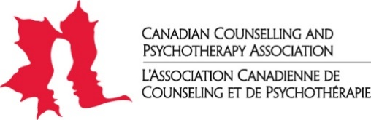

Publications Order form

NOTE - Please print or type GST Registration #13121 2979 RT0001

Name |  |  |  |  |  |  | Organization
Mailing Address
City |  |  |  |  | Province |  |  | Postal Code
Phone |  |  |  |  |  | Email
CCPA Member? |  |  | Yes |  | No |  |  | If Yes, Member #

Product | Member Price | Quantity  (Max. 1) | General Price | Quantity | Total Price  *Please note that shipping charges will be added to the final price
Ethics-Based Issues and Cases | $49.95 |  | $55.95
CCPA Standards of Practice | $10.00 |  | $14.00
CCPA Code of Ethics | $3.00 |  | $3.00
Supervision of Counselling and Psychotherapy Handbook | $25.00 |  | $30.00
Clinical Supervision of the Canadian and Psychotherapy Profession Manual | $59.95 |  | $65.95
Handbook of Counselling and Psychotherapy in Canada | $59.95 |  | $65.95
Sub-Total:
Shipping (To be completed by CCPA Staff):
Grand Total:

Method of payment: Cheque*: Credit Card: MasterCard Visa American Express
Credit Card #: _________________________________________ Expiry Date: _______/________
Name (please print) : ______________________________________ CVS : ____________________

Signature: ___________________________________________ Date: ________________________

*If you are sending a cheque, please contact CCPA at reception@ccpa-accp.ca for accurate shipping charges.

Options for submitting completed form:
1. Email form to reception@ccpa-accp.ca.
2. Print and fax form to: 613-237-9786
3. Print and mail form to:
6-203 Colonnade Rd S
Ottawa, ON, K2E 7K3
CCPA is committed to providing a safe, healthy and respectful working environment for its employees, expressly free from discrimination, bullying and harassment. CCPA strives to provide its members with the best services possible but in doing so will not tolerate abusive, aggressive nor disrespectful language or behaviour towards our staff or our members.

